All Wales People First


Annual General Meeting 2024/2025

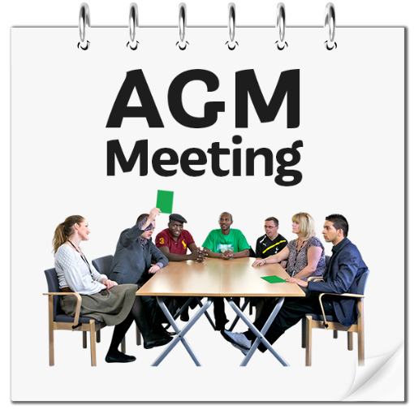

Wednesday 25th June 2025, time 10.30 am
Kinmel and Kinspa Hotel, Abergele

Agenda
Wednesday 25th June 2025

- Welcome
(Lucy Hinksman and Kurtis Marshall, the Chair and Vice Chair of the All Wales People First National Council).

- Apologies for Absence
(Lucy Hinksman and Kurtis Marshall, the Chair and Vice Chair of All Wales People First National Council).

- Minutes and Matters arising from the Annual General Meeting held on 7th March 2023
(Lucy Hinksman and Kurtis Marshall, the Chair and Vice Chair of All Wales People First National Council).

4. The 2024/2025 Annual Report (Highlights)
Joe Powell (Chief Executive Officer, All Wales People First).

5. Questions and Answers
Members chance to ask questions on the Annual Report.

6. The Finance Report
Victoria Sidwell-Brown (Business and Finance Manager, All Wales People First).

7. Questions and Answers
Members chance to ask questions on the Finance Report.

8. Adopting the Annual report
Members to adopt the report.

9. Retirements from the Board of Directors
- Bob Rhodes
- Michael Alcock

10. The National Council 2024/2025
Lucy Hinksman (Chair of the All Wales People First National Council).

11. Any Other Business

12. Thanks and Close
Lucy Hinksman (Chair of the National Council).

