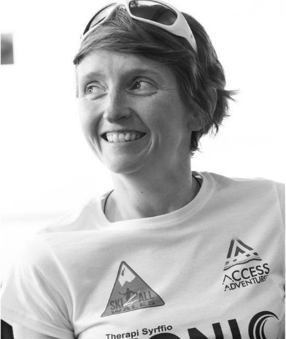**Tina Evans, Human on Wheels talking to the Through our Eyes on Tour celebration event in Bangor, 2nd December 2024**

Firstly,  congratulations on a successful and empowering project.

The saying is 'nothing about us without us' and that was clearly at the heart of this project.

I’m here today to talk about how we can change stereotypes and public perceptions? And the representation of disabled people in the media.  I don’t have a learning difficulty, but I am part of the wider disability community of which we share.

Just a bit about my background, after studying theatre film and TV studies at University I landed my first job as a researcher at BBC Cymru. I got the job through the extend scheme which is a scheme for disabled people, to work in different departments within the BBC. This scheme is still available and a positive step to encourage disabled people to work at the heart of the production. We can influence the content created and how disabled people are seen.

After 3 years at radio Cymru, I did some work on creating a contributors database- if it was used it would've been great. We noted people’s expertise but also they're interests.

For example, I'm sure I'm the only Welsh speaking disabled person in Wales as Welsh news always ring me to talk about disability issues.  Raising our voice on accessibility issues is important but it's a balance, it's about seeing the person as well, the person who can talk about sport, Raising a family or review films.

In 2022 I was invited to be part of the BBC presenting team at the commonwealth games. I spent 2 weeks in Birmingham and I reported on non disabled competitors as well as disabled competitors. This was a positive step in my eyes, as it was not about my impairment, but about my ability to be a good reporter on screen. I was being seen.

I am now part of the ‘’clwb clecs’ group on the s4c magazine programme Prynhawn Da. I get called in monthly and we discuss the light news of the week, for example when they announced dogs were aloud into some shops. We would share our views. Again this is a positive step forward, as my impairment is not the focus but I am being seen.

Last year, I was asked to join the production team of Pawb ai farn, which is like the Welsh version of question time. The episode was focused on disability issues. My role was to find contributors, and I wanted to have representation from a wide range of impairments.  I wanted everyone to be seen and heard.  As disabled people we share the same issues, but as you go beneath the umbrella, each individual community have their more specific issues, and I wanted everyone to have a voice.

Faye represented the learning disability community, and spoke well.

It was the first programme on S4C to have a live BSL interpreter, which meant Sara Lawrence could represent the Deaf community.

This year I took part in Wales triathlon series, as part of a relay team.  The series was televised, and I personally think it was done well, with showing the elite athletes and our story.  There was no pity story, it was about me, a disabled athlete succeeding in events with the support of my team.

I was the first disabled athlete to complete the series.

There are triathlon events for disabled athletes but I wanted to take part in these events with non disabled athletes to close the division and integrate. I was being seen, participating like everyone.

I also think this is one way of changing public’s perception, as I spent time with the other triathletes and closed the gap of communication between us. Appearing on the TV series meant I was seen by a  new larger audience.

S4C, BBC and ITV are all doing some work their disabled people’s schemes and having a disability officer who run disabled people’s steering groups.  Could they do more? Of course and I hope that the steering group are raising their voices. Without disabled people being at the heart of a production team, guiding the way, change won’t be possible. We need both disabled people and non disabled people working together and sharing expertise to create content that ensures we are all visible in society.

I  believe if something is not available then you create it.   I enjoy going to Banff film festival every year where they show adventure documentaries. After watching the first one, there was no representation of disabled people so I decided I’d do something about it.  My friend and I cycled on a tandem from Cardiff to Paris and made a film of the journey. Unfortunately it didn’t get selected but we will run events next year to show the film. And maybe into schools, where we use media to educate at the roots.

My 2025 will focus on these events and a creating a podcast with my friend, which will be centred around friendship, and sharing the joys of adventure, with or without a disability.

The internet has changed the media. YouTube is being watched on tv as much as tv channels, and we the people control the channel.  We are the content creators. My nephew will sit and watch someone playing a computer game. He finds it very amusing, I don’t understand the joy of it myself. But you can create videos of your interests.

Maybe your next step is to bring these photos alive on YouTube? Create your own content.

Continue your great work here of being in the driving seat, and showing how your community is seen.