 | The M.I.R.R.O.R. Awards 2024
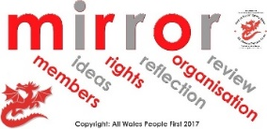 | We are having our MIRROR awards ceremony at AdFest on 19th June  The awards are to celebrate the great things  self-advocates and groups have done over the last year.
There are 6 awards.

You can nominate yourself, or someone else, for 1 or more of the awards.
 | The 6 awards are
- Members – Linton Gower Memorial Award
This award is for a member, or members, who have done something outstanding towards the running of their Self-Advocacy group.

- Ideas
This award is for a member, or a group, who have worked with others on an idea.
The idea should be something that improves the lives of people with learning disabilities in Wales.

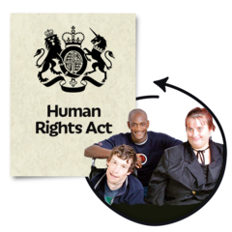 | - Rights  This award will go to a member or group who has helped people know about their rights.
- Reflect
This award will go to a member or group who can show they have learnt from their experiences and made a change.

- Organisation
This award is for a group that has worked together to be a strong group and included everyone.

- Review
This award is for a group or member who has achieved something special.

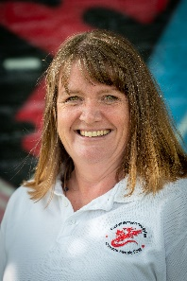  Tracey  07956  082211  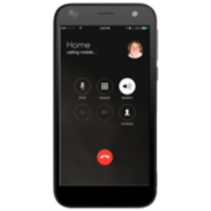  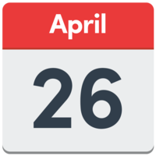 | You can enter yourself or someone else for an award by emailing or phoning Tracey to tell her:  - Who you want to win the award  - Which award you think they should win  - Why you think they should win it  - Your contact details so we can find out more  You can email Joe at  joe@allwalespeople1st.co.uk  Or you can phone Joe on 07972 516328.  This year we would also like you to send a short video clip (about 30 seconds), or photographs, of the person you are nominating.  This is to show the work they do, and/or what they have achieved.  This can be filmed on your phone.  If you need any help or further information about this contact Tracey.  All nominations must be received by Friday 26th April at 5pm.  Shortlisting for the awards will be from 21 – 24 May  The winners will be chosen by the Co-Chairs of the AWPF Board of Directors.
 | The winner of each award will be announced at the awards ceremony during AdFest on June 19th 2024.

