Position Statement
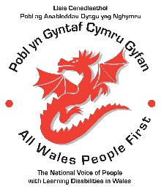
Day Centres
Lots of people with learning disabilities rely on day centres.

Day centres are where many people with learning disabilities make friends and feel a sense of belonging.

They can play an important role in reducing isolation and loneliness.

“I’ve made lots of friends at the day centre and I’d be bored stuck in the house. It’s great for making friends and having a chat”

“Some people can’t access their self-advocacy group and they need day centres”

Lots of people with learning disabilities prefer other ways of meeting their wellbeing needs.

“I left day centre because it wasn’t for me. It was for people with more complex needs. I can get out a lot independently”

Whilst day centres may not be right for everyone with a learning disability it is important that those who choose to use a day centre are able to access them.

Choice was taken away at the start of the Covid lockdown in early 2020, and opportunities to return to day centres have not resumed for many people.
“There’s one day centre open in the whole of Ceredigion”

“I’ve been part of a campaign group to get our local day centre to re-open”

For those members who have returned to day centres, the hours available to them are not as many as pre-Covid.

The absence of day centres has certainly increased the demand for facilitated self-advocacy services in most areas throughout Wales.

Yet there has been no additional funding for self-advocacy groups to meet the increased demand.

“Self-advocacy groups are picking up the slack where day centres have closed”

Calls to action
We call on Welsh Government to ensure that day centres throughout Wales are available to those who choose them and need them.

We call on Welsh Government to ensure that people with learning disabilities receive day centre hours and services as laid out in their care plans.

We call on Welsh Government to ensure that facilitated self advocacy is adequately funded in each county throughout Wales.

NOTHING ABOUT US WITHOUT US!
Tracy Austin, Chair of the National Council
In consultation with the All Wales People National Council and members.
All Wales People First

