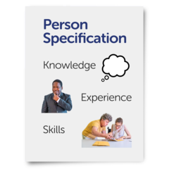 | Person with lived experience to  work on advocacy project  Person Specification | 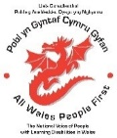  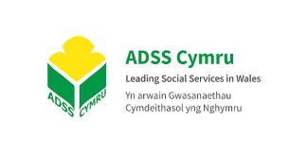

Requirement | Essential | Desirable
Education, Training and Qualifications  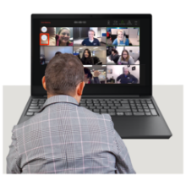 | Basic knowledge of IT:  - Word  - PowerPoint  - Emails  Able to host Zoom or other social platforms.
Skills and Knowledge  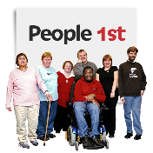 | Has been supported by an Independent Advocate.  Understanding of self-advocacy. | Understands the principles of Easy Read.  Welsh language speaker.  Working collaboratively with organisations from voluntary and public sector
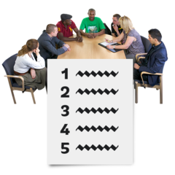  Experience  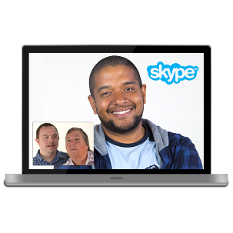  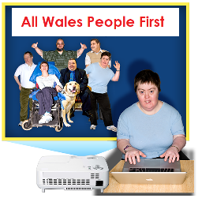 | Able to speak to large groups of people.  Delivering Power Point presentations.  Comfortable speaking on video or Podcast.  Has lived experience of learning disability. | Experience of working in a member led organisation.
Personal attributes  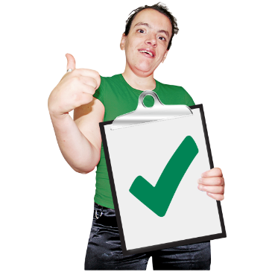 | Friendly and approachable and able to work in a collaborative way.  Highly motivated, flexible and resourceful.  Positive and outgoing personality.  A non-judgemental attitude.

