All Wales People First

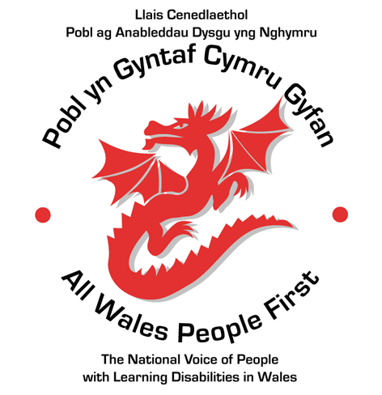
Annual General Meeting 2022

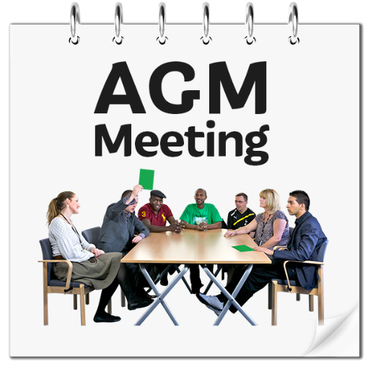

Tuesday 7th March 2023, time 5.30 pm
Holiday Inn, Newport
and on Zoom

Agenda
Tuesday 7th March 2023

- Welcome

- Apologies for Absence

- Minutes and Matters arising from the:

- Annual General Meeting held on 5th October 2021 and
- Extraordinary General Meeting held on 22nd June 2022
Members’ chance to discuss things from the minutes.

3. The 2021/2022 Annual Report (Highlights)
Joe Powell (Chief Executive).

4. Questions and Answers
Members chance to ask questions on the Annual Report.

5. The Finance Report
Victoria Sidwell-Brown (Business and Finance Manager, All Wales People First).

6. Questions and Answers
Members chance to ask questions on the Finance Report.

7. Adopting the Annual report
Members to adopt the report.

8. Retirements from the Board of Directors
John Thomas
Bob Rhodes

9. The National Council 2021/2022
James Tyler (Chair of the National Council).

10. Any Other Business

11. Thanks and Close
James Tyler (Chair of the National Council).

Minutes of the AWPF Annual General Meeting held at the Marriott Hotel, Cardiff and via Zoom on 5th October 2021.
Present: see end of minutes
The Vice-Chair of the National Council, Simon Richards, welcomed everyone to the meeting.
He asked those present if they were happy to have their photographs taken. All agreed.
- Minute’s Clap for Linton Gower: Simon started the meeting with a minute’s clap for Linton Gower (previous Vice-Chair of AWPF) and other members who had sadly died since the last AGM.

- Minutes and Matters Arising from the meeting held on 7th October 2020: Simon asked people to take a few minutes to read through the minutes and invited questions.
A vote was taken and the minutes were approved as a correct record. (34 votes in favour)
There were no matters arising.

- 2020/21 Annual Report: Chief Executive Joe Powell gave a summary of the report and highlighted the following points:

- Hear Me, Include Me, Respect Me: this project started during the year. Because of Covid we had to do things differently. One of the positive outcomes from the Covid pandemic is that social inequalities and injustices are better understood by politicians. We have also seen members showing great signs of leadership (e.g. Ffion Poole and Michelle Williams).
- Communications: we were able to share a lot more members’ stories than we had anticipated. Joe thanked people for sharing their stories.
- Hate Crime Survey: Welsh Government are producing the first ever hate crime statistics in Wales.
- Engage to Change Project: AWPF is no longer a partner in this project, but we continue to run evaluation forums for the partner organisations.

- Questions and Answers: there were no questions about the Annual Report.

- Finance Report: Victoria Sidwell Brown (Business and Finance Manager) explained the organisation’s accounts and shared information on Income and Expenditure.
She said that 3 new staff members had been appointed in April 2020 as part of the Hear Me, Include Me, Respect Me Project. This had also been the first year of the Photography Project ‘Through our Eyes’.
She said that income rose significantly because of the new projects. Welsh Government would not allow us to carry forward any underspend accrued because of Covid, although other projects did allow this.

- Questions and Answers: there were no questions

- Adopting the Annual Report: a vote was taken, and members agreed to adopt the Annual Report. (36 votes in favour)

- Retirements from the Board: Donna Reeve and Margaret Flynn are required to stand down from the Board at this meeting. Both are active members of the Board and would like to re-stand.
Donna Reeve: re-elected (27 votes)
Margaret Flynn: re-elected (28 votes)
- The National Council 2020/21 James Tyler, Chair of the National Council said that National Council meetings have been happening more frequently for shorter periods of time. In February 2021 an election to the National Council meant that we said goodbye to some reps and welcomed new ones. These new reps are getting to know each other online. We have continued to speak up at the highest levels to promote self-advocacy for people with a learning disability. We were joined by Mark Isherwood, MS, for our Manifesto launch and this included a call to reduce the use of restraints. The National Council has joined the Citizen Network and vote to apply to join Inclusion Europe.
The National Council has looked at conflicts of interest with the Board of Directors.
We held our 30th birthday celebration online in 2020 as part of Adfest celebrations.
James said he was very pleased to have joined the National Council this year and to have been elected as Chair.

- Proposed Changes to Memorandum and Articles of Association:

Joe explained that there were various changes which we wished to make to the Memorandum and Articles which form the rules for the organisation. The meeting voted on each one as follows:

- The National Council should meet 4 times a year. Agreed: 32 votes
- Regional Council and subgroups should be included in the Mem and Arts. Agreed: 28 votes
- The Board can choose 3 extra people to sit on the Board, these people can vote, the Board must tell the National Council about them, and the National Council can refuse but only if they have a good reason. Agreed: 30 votes
- Board members can stay on the Board for 9 years including any time on the Board as the NC Chair or Vice Chair: Agreed: 31votes
- Co-chairs of the Board can have the casting vote if a vote on a decision is tied. Agreed: 33 votes
- Co-chairs for the Board should be chosen every 2 years. Agreed: 32 votes
- The role of the Board is to give advice to and seek advice from the National Council: Agreed: 33 votes
- The National Council should decide on a list to describe what a member of AWPF should be like and a list to describe who cannot be a member. Agreed: 32 votes
- The National Council and the Board should meet once a year. Agreed: 33 votes
- Under 18’s cannot be members of AWPF: Agreed: 34 votes
- Votes at the AGM will be decided with a majority vote. The National Council can decide to change the number of votes needed for decisions. Agreed: 33 votes

11. Thanks and Close: James Tyler thanked everyone for attending and closed the meeting.
Present:
Board members: Bob Rhodes, Donna Reeve, Ruth Northway, Lee Ellery, Simon Richards, James Tyler
Staff: Joe Powell, Victoria Sidwell Brown, Tracey Drew, Natasha Hirst, Gerraint Jones Griffiths, Sarah Ansell, Kelly Stuart, Philippa Davies, Lucy Hinksman.
Members: Carl Fowler, Hannah Thomas, Chloe Cannon, Nicole Bird, Sophie Scheeres, Donna Yule, Clive Edwards, Anita Clasby, Kelly Ball, Samantha Hall, Lauren Olwyn Jones, David Weir, Matthew Heit, Dave Sweeting, Danielle Wagstaffe, Mathew MacDonald, Adam Bartle, Kurtis Marshall, Rosie Williams Jones, Raymond Byles, Ian Swannick, Connie Phibben, Kara Williams, Richard Williams, Ffion Poole, Richard Redmond, Rhiannon Currie, David Whittle, Rebecca Chick, Bradley O’Keefe, Alex Wooler, Lynne Evans, Sarah Griffiths, Rhiannon Currie, Bethan Kench, Sophie Wakeling, Bryn Owen, Richard Redmond, Harry Rendell, Rebecca Morgan, Tina Larner, Ope Abidogun.

In attendance: Claudia Magwood, Rachel Staphnill, Jan Walmsley and support staff for members.

Minutes of the AWPF Extraordinary General Meeting held on 22nd June 2022 at the Quay Hotel, Deganwy (and on Zoom).
The meeting opened at 12:10pm.
The meeting had been adjourned to the 22nd June because the first EGM on the 3rd May 2022 was not quorate.
Present: 43 full members in the room and 3 on Zoom. The meeting was quorate.
James Tyler, Chair of the National Council introduced the Chief Executive Joe Powell.
Joe explained that AWPF wanted to make some changes to the memorandum and articles of association. They were known as special resolutions. They have been discussed at length and agreed by members at the AGM on the 5th October 2021, but we had not filed them with Companies House within the required time frame. Joe read through the changes agreed at the October AGM and asked if AWPF could still make those changes. The Members voted 100% in agreement. The changes were:
- The National Council should meet four times a year.
- Regional Councils and sub-groups should be included in the Mem and Arts.
- The Board can choose 3 extra people to sit on the Board, these people can vote, the Board must tell the National Council about them, and the National Council can refuse but only if they have a good reason.
- Board members can stay on the Board for 9 years including any time on the Board as the National Council Chair or Vice Chair.
- Co-chairs of the Board can have the casting vote if a vote on a decision is tied.
- Co-chairs for the Board should be chosen every 2 years
- The role of the Board is to give advice to and seek advice from the National Council.
- The National Council should decide on a list to describe what a member of AWPF should be 6 like and a list to describe who cannot be a member.
- The National Council and the Board should meet once a year.
- Under 18’s cannot be members of AWPF.
- Votes at the AGM will be decided with a majority vote. The National Council can decide to change the number of votes needed for decisions.
He then told the members of three more proposed special resolutions and asked the members to vote on them.
He asked members to vote on the following questions:
- Can AWPF change the Companies Act on its Mem and Arts from 1985 to 2006? Agreed 100%
- Can AWPF merge its Memorandum & its Articles of Association into one document? Agreed 100%
- Can the new Mem & Arts (or rules) replace the old Mem & Arts? Agreed 100%
The Chief Executive thanked everyone for attending and closed the meeting.
The meeting was closed at 12:25 pm

