[Put your address here]
 | Dear [Put your MP’s name here]
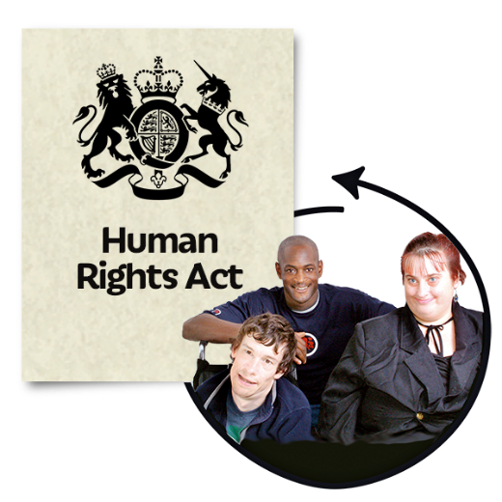 | I am writing about the UK Government Human Rights consultation. It is called Human Rights Act Reform: A Modern Bill of Rights. A consultation to reform the Human Rights Act 1998.
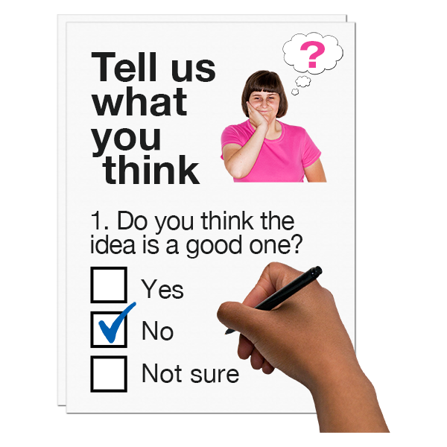 | As a person with learning disabilities I am very upset the UK Government has not thought about how I might participate in the consultation.
 | There are lots of problems with the consultation. All of the problems are listed in the attached letter.
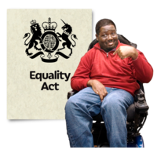 | The letter is to the Joint Committee on Human Rights.  As my MP, I am asking you to represent my views, and the views of others with learning disabilities expressed in the letter.  Please let the Ministry of Justice know that their consultation has failed to include me as fully and equally as non-disabled people.
Yours sincerely

[put your name here]

