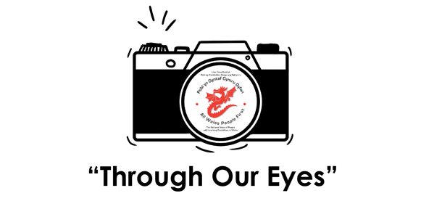

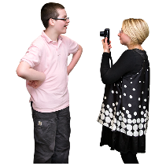
What is a photoshoot
A photoshoot is when a professional photographer takes lots of photographs of someone or people in the same place. The photos might be used online or in a magazine.
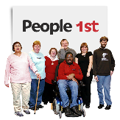

We will take photos and videos of people with Learning disabilities
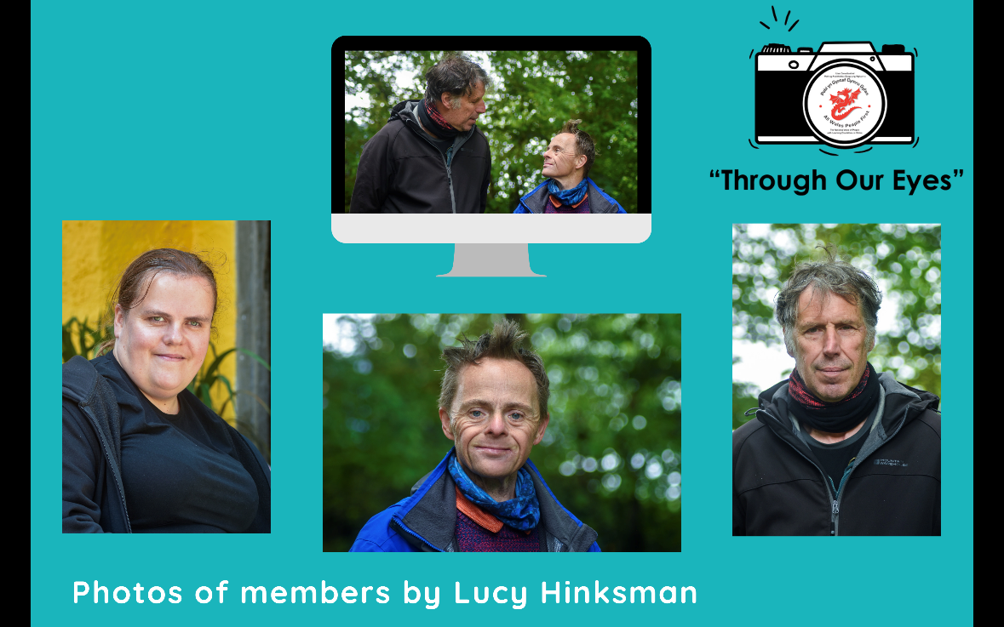

How we do a photoshoot
We have to choose somewhere to take the photographs
Outdoors or indoors.
-if indoors, lots of natural light is best

We then gather props such as a chair or a stool etc

-if outdoors we like parks, beaches and interesting places

We then prep members before we begin
- Thinking about the style of pose we would like
- Portrait – smiling looking straight at the camera
- Capturing the members personality

The shoot
- We prepare our cameras, make sure our settings are correct and make sure the lighting is good
- We may have a tripod ready and have it set up in the right angle
- We ask you to try out different poses and try different expressions in a creative way
- We will then edit your photos using photo editing software

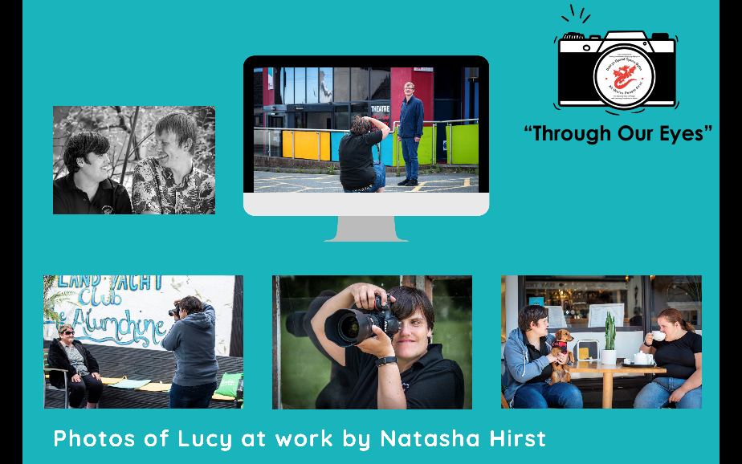

We will use our photos in
- Newsletters and reports

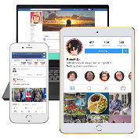
- Online. Online means on social media and on websites
- (When photos are online anybody can see and share them)

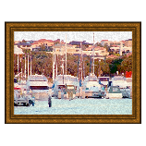

- In an exhibition at the end of the project
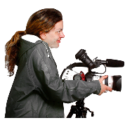

Some photos and video will be used by the media.

Some photos might be in:
- Newspapers
- Magazines

- News on TV

Please let us know if you would like to take part in a photoshoot.

Contact
lucy@allwalespeople1st.co.uk
natasha@allwalespeople1st.co.uk
or phone Claire on 07399 059631

