PRESS RELEASE

Learning Disability LGBT Action Group supports Welsh Government’s proposed LGBTQ+ Action Plan

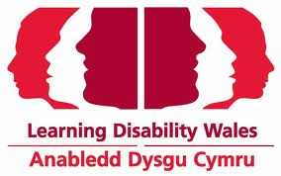 | 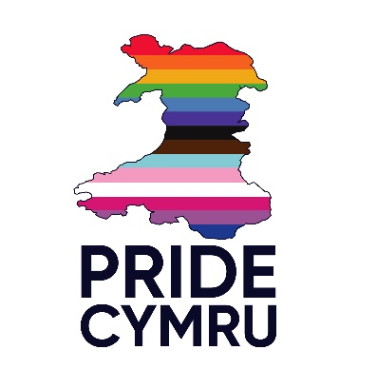 | 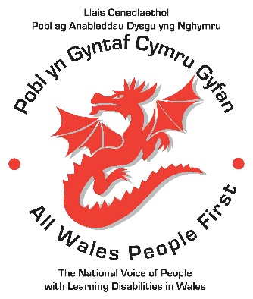
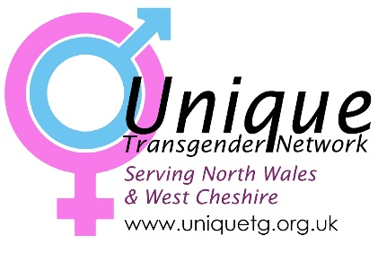 | 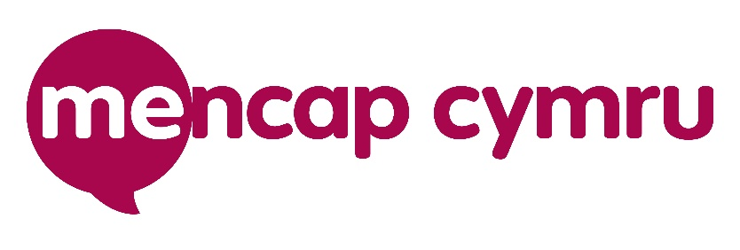

The Learning Disability LGBT Action Group, which includes, Learning Disability Wales, Mencap Cymru, Unique Transgender Network, Pride Cymru and All Wales People First support the provisions, as laid out in the Welsh Government’s proposed LGBTQ+ action plan for the inclusion of trans and non-binary people.
As a group committed to equal rights for all people with learning disabilities, we support the individual’s choice to define their own gender. We do not draw any distinction between women’s rights and trans rights.
We believe that Trans Women are Women, Trans Men are Men, and Nonbinary identities are valid identities.”

Joe Powell, Chief Executive All Wales People First
On behalf of the Learning Disability LGBT Action Group

Notes to Editors:

For further information and interviews please contact:
Joe Powell, Chief Executive, All Wales People First on 07972 516382, email joe@allwalespeople1st.co.uk

Zoe Richards, Chief Executive, Learning Disability Wales on 02920681170, email zoe.richards@ldw.org.uk

Wayne Crocker, Director, Mencap Cymru, email wayne.crocker@mencap.org.uk
Sian Davies, Head of Strategic Programmes, Mencap Cymru sian.davies@mencap.org.uk
Mencap Cymru Helpline: 0808 8000 300

Jenny Anne-Bishop, Chair of Unique Transgender Network, 07500 741955, email jennyannebuk@btinternet.com

All Wales People First
All Wales People First is the united voice of self-advocacy groups and people with learning disabilities in Wales. It is an organisation for, and led by men and women with a learning disability. It is unique in Wales in that it is the only national member-led organisation that represents the voice of men and women with a learning disability www.allwalespeople1st.org.uk

Learning disability Wales
We want all people with a learning disability to live as independently as possible in a place that they choose, and to have control over their lives. www.ldw.org.uk

Mencap Cymru
Everything we do is about making sure people with a learning disability are valued equally, listened to and included www.wales.mencap.org.uk

Pride Cymru
Pride Cymru is a volunteer-led charity that works to promote the elimination of discrimination be it on the grounds of sexual orientation, gender, race, religion or ability.
www.pridecymru.com
Unique Transgender Network
UNIQUE Transgender Network is a constituted voluntary group supporting Trans (transgender, gender diverse and non-binary) people in North Wales & West Cheshire. Unique's prime aim is to help Trans people accept themselves and find integration in the wider community.
Home (uniquetg.org.uk)

Welsh Government LGBTQ+ Action plan for Wales
https://gov.wales/sites/default/files/consultations/2021-07/lgbtq%2B-action-plan.pdf

Welsh Government consultation on the LGBTQ+ Action Plan
https://gov.wales/consultation-lgbtq-action-plan-html

