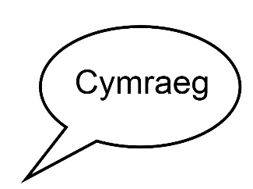 | Welsh language policy
Agreed by Board on 12.2.18

Date for next check: February 2020

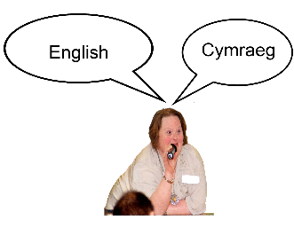 | Wales has two main languages, Welsh and English.
 | All Wales People First believes both languages are important.
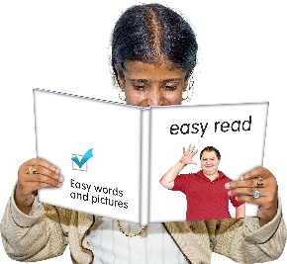 | We believe it is important to use clear, plain Welsh and English.
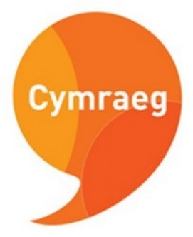 | At the moment, All Wales People First uses English as its main language.
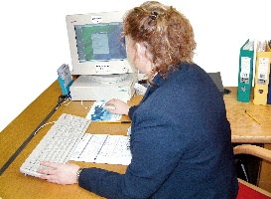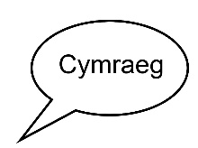 | In future, we want to do all our work bilingually. Bilingually means in two languages.
 | We will look for funding and other things to help us offer more services bilingually.
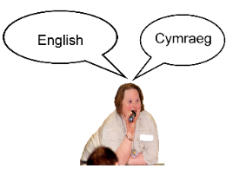 | When we apply for grants, we will include money to do the work in Welsh and English.
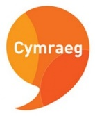 | When we plan our work, we will think:  - what needs to be done in Welsh,  - what needs to be done in English  - what needs to be done bilingually
 | We will:
 | - support staff to have Welsh awareness training.
 | - give staff the chance to learn and use more Welsh
 | - have a Welsh Language Champion to make sure we remember to think about Welsh and English when we plan our work
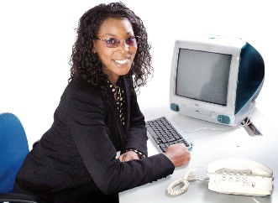 | - give a badge or lanyard to staff who are happy to use Welsh at work
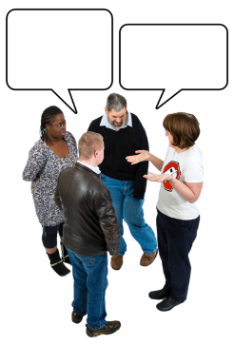 | - When needed, we will use a qualified translator when we translate from English to Welsh
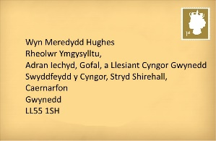 | - reply in Welsh to letters or emails we receive in Welsh
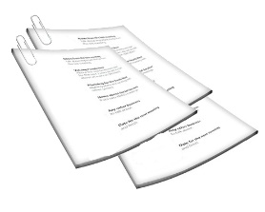 | - say (bilingually) on our headed paper and emails that people can write to us in Welsh or English
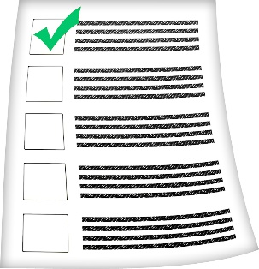 | - have a list of people in All Wales People First who can speak and write in Welsh
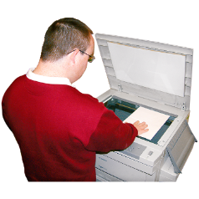 | - Whenever possible, we will communicate bilingually on Facebook and Twitter.
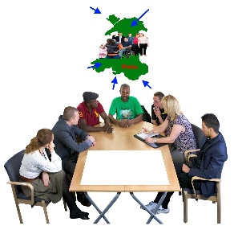 | When we organise public meetings, we will advertise them bilingually.
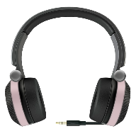 | If more than 20% of the people coming to a public meeting want to use Welsh, we will arrange translation. If we can’t afford translation headsets, we will ask someone to translate people’s questions and answers.
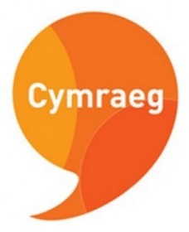 | We have made sure that our logo is bilingual.
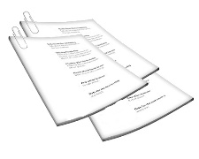 | We will do our best to provide all printed information for the public in Welsh and English. If we can’t, we will write down the reason why.
 | Our website will let people choose Welsh or English.

 | Every year, we will review:
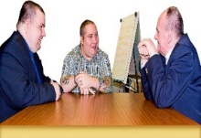 | - our list of staff, members and Board members who can speak, read and write in Welsh
 | - what we have done to encourage more people to use Welsh
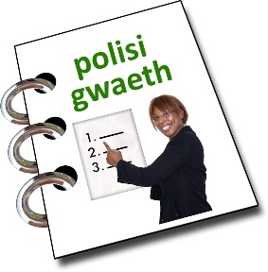 | - how we are doing at following this policy

