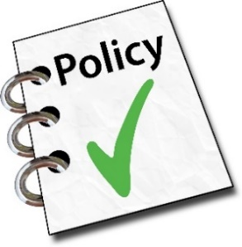 | Equality and diversity policy
Agreed by: The Board on 12/11/19

Date for next check: 12/11/21
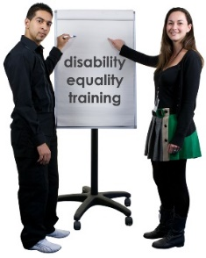 | Equality means treating everyone fairly, not treating everyone the same.
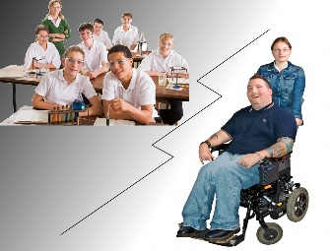 | Diversity means people are different from each other.

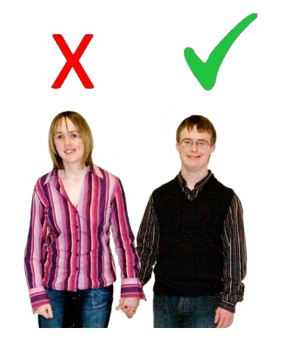 | Discrimination means
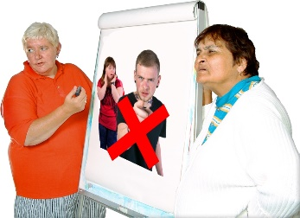 | - treating some people differently than others. This can mean positive or negative discrimination. Or
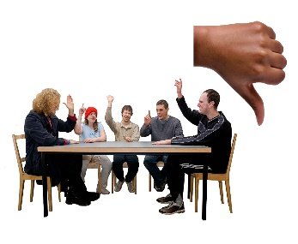 | - making it hard for some groups of people to belong to our organisation.
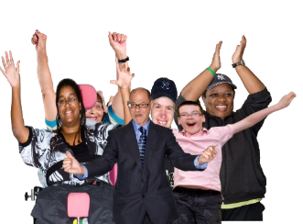 | Our organisation will treat everyone fairly.
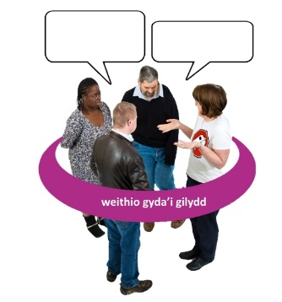 | Our organisation thinks we are stronger when different people work together.
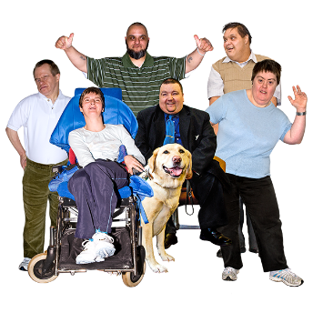 | Our organisation is for people with learning disabilities and Autism Spectrum Conditions (ASCs).  We want anyone with learning disabilities and ASCs to be able to join our organisation, feel safe and be treated fairly.
 | We want to welcome people with learning disabilities and ASCs whatever their:
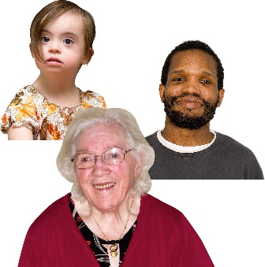 | - age
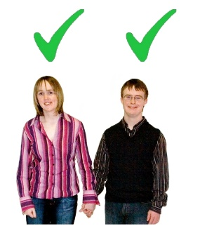 | - gender
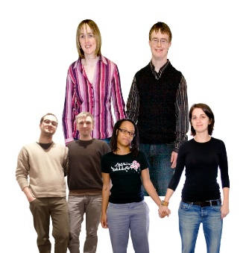 | - sexuality
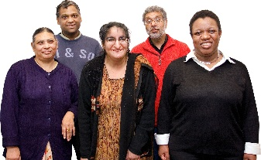 | - ethnicity or skin colour
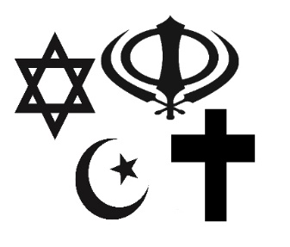 | - religion or beliefs
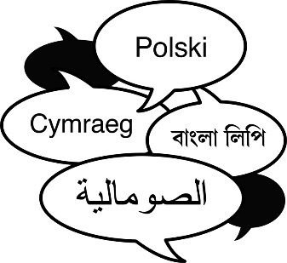 | - language or communication method
 | - income
 | - disability
 | We want to welcome people whether or not:
 | - they have a partner
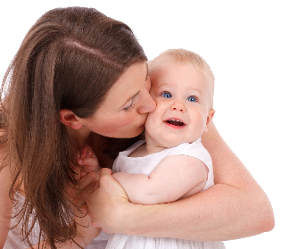 | - they have children
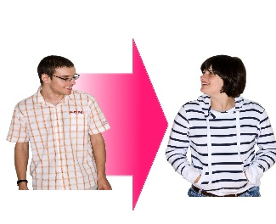 | - they change whether they live as a man or woman
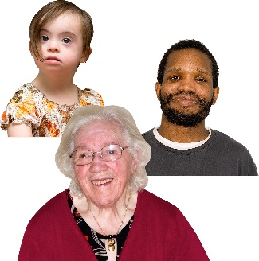 | We will look at the list of ways people can be different from each other.
 | At least once a year, we will check if we have different types of people as:
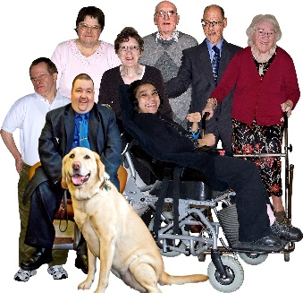 | - members
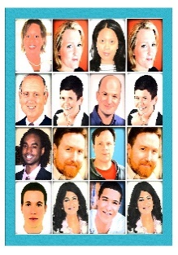 | - staff
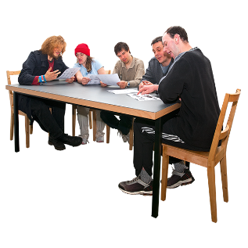 | - board members
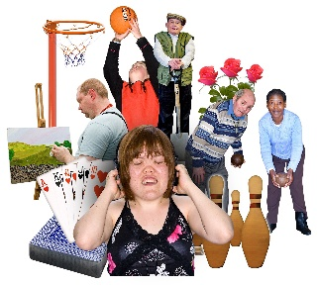 | - people who come to our activities
s | We will check if some people are missing from our organisation.
 | If some people are missing, we will try to find out why. We will see how we can change so they feel welcome.

 | Members
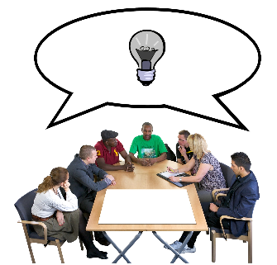 | We will think about all our members when we plan activities.
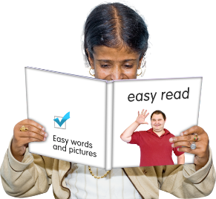 | We will make sure information is easy for them to understand.
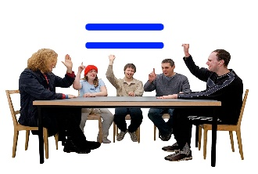 | We will encourage members to talk about equality, diversity and discrimination.
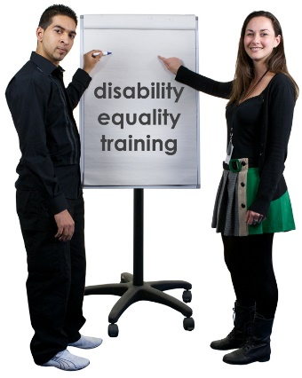 | We will encourage members to help our organisation find new and better ways to treat people fairly.

Board
We will think about all our Board members when we plan Board meetings.
We will make sure information is easy for them to understand.
We will encourage Board members to talk about equality, diversity and discrimination.

 | Staff
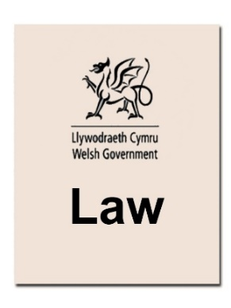 | The law protects people who apply for jobs and staff from discrimination.
 | We will think carefully about how we advertise, recruit, train and support staff.
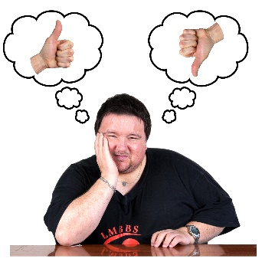 | We will find out what makes it harder or easier for some groups of people to get and keep jobs.

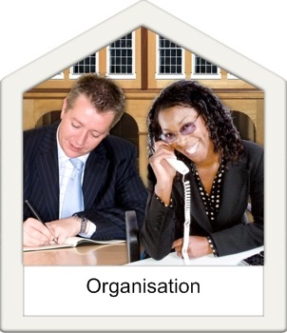 | Other organisations
 | We will look for opportunities to help other organisations to include people with learning disabilities.

