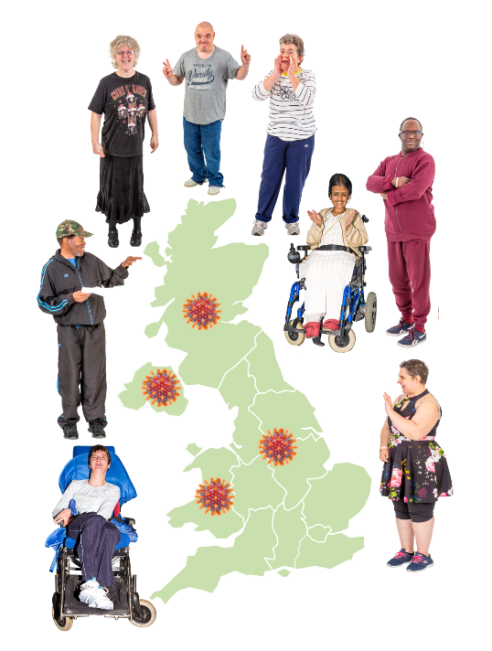

Coronavirus and people with learning disabilities study
What is life like for people with learning disabilities?

This study started in September 2020.

Researchers ask people questions to find out new information.

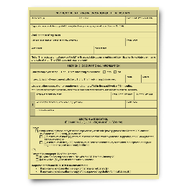 | There are other studies about coronavirus (COVID-19). These studies are hard for people with a learning disability to take part in.  The voices of people with learning disabilities were not being heard.  Researchers did this study to hear from people with learning disabilities themselves.  The report is very important because so many people with learning disabilities took part and told their own stories.
 | 621 adults with learning disabilities told the researchers about their lives during COVID-19.
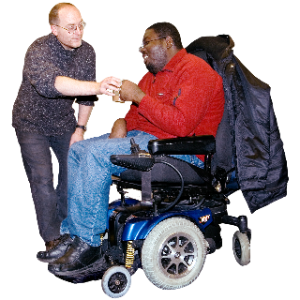 | Some adults with learning disabilities were not able to talk to researchers.  The researchers also asked 378 family carers or paid support staff questions about the lives of these people with learning disabilities.
 | The researchers talked to people in England, Northern Ireland, Scotland and Wales.
They talked to people with learning disabilities to check what questions to ask.

They asked questions that were important to people with learning disabilities and their families.

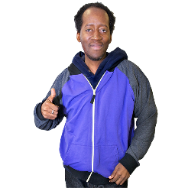 | This is what the researchers have found out.
Around 8%-10% of people with learning disabilities thought they had caught COVID-19.

Some of them went to hospital.
People with learning disabilities told us they knew people who had died from Covid-19.

Just over 10% of people with learning disabilities said someone close to them had died due to COVID-19.

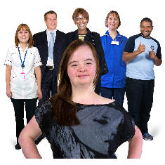 | People with learning disabilities are getting less help with their health.  Less than half of people with learning disabilities have seen their doctor since lockdown started.
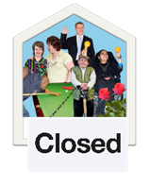 | Community activities have stopped.  Day centres have closed.
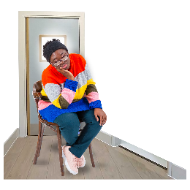 | Lots of people with learning disabilities have been lonely.  They are lonely because lockdown stopped their friends and family visiting.
Many people with learning disabilities are worried about getting COVID-19.

Many people with learning disabilities are more worried about their friends and family getting COVID-19.

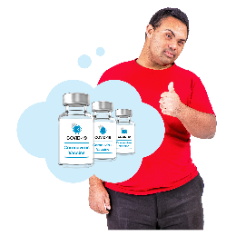 | Most people with learning disabilities would take the COVID-19 vaccine if it was offered to them.
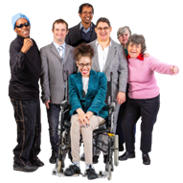 | 3 out of 10 people with learning disabilities said they had a job before COVID-19.  Some of these people have had to learn to work from home  These results will be shown to people who can change things to make life better for people with learning disabilities.  People with learning disabilities, family members, and the researchers will do this together.
 | UK Research and Innovation have paid for this research.
There is an Easy Read summary of the research. You can read it here:
https://warwick.ac.uk/fac/soc/cedar/covid19-learningdisability/results/wave1results/easyreadreport

If you want to find out more about this study, you can look at this website:

www.covid19learningdisabilities.co.uk

NOTES

The project, COV0196 - The impact of Covid-19 and associated social restrictions on people with learning disabilities, their families and social care support workers, has been funded by the UKRI-DHSC COVID-19 Rapid Response Rolling Call.

The full report - Coronavirus and People with Learning Disabilities Study Wave 1 Results: March 2021 (Full Report) – will be available here: https://warwick.ac.uk/fac/soc/cedar/covid19-learningdisability/results/wave1results/fullreport
The highlights document - Highlights from the full report (Wave 1 - March 2021) – will be available here:
https://warwick.ac.uk/fac/soc/cedar/covid19-learningdisability/results/wave1results/highlights

The Easy Read highlights document - Coronavirus and People with Learning Disabilities Study: What we know so far (Easy Read) – will be available here: https://warwick.ac.uk/fac/soc/cedar/covid19-learningdisability/results/wave1results/easyreadreport

Principal Investigators and Co-investigators: Prof Chris Hatton (Manchester Metropolitan University); Prof Richard Hastings (University of Warwick); Prof David Abbott (University of Bristol); Dr Stephen Beyer (Cardiff University); Dr Jill Bradshaw (University of Kent); Dr Nick Gore (University of Kent); Prof Pauline Heslop (University of Bristol); Prof Andrew Jahoda (University of Glasgow); Anna Marriott (National Development Team for Inclusion); Dr Katrina Scior (UCL); Dr Laurence Taggart (University of Ulster); Dr Stuart Todd (University of South Wales)

Third Sector participants: All Wales People First, Learning Disability Wales, All Wales Forum of Parents and Carers of People with Learning Disabilities, Scottish Commission for Learning Disability, Promoting a More Inclusive Society (PAMIS), Positive Futures, Mencap Northern Ireland, Learning Disability England, PMLD Link, Positive Futures, CAN Northern Ireland, Families Involved in Northern Ireland (FINI).

Press inquiries first point of contact: Kelly Stuart, Policy and Communications Manager, All Wales People First kelly@allwalespeople1st.co.uk 07508228474

