All Wales People First
All Wales People First Outreach Worker
Job Description

Salary: £8, 927.43 (pro rata)

Hours of Work: 15 hours per week
Pension: Employers Contribution 6%
Employees Contribution 2%
Accountable to: Member Engagement Advisor

Location
You will mostly work across Wales and will occasionally be required to travel across Wales.
Occasional overnight stays away from home will be required.
The post involves working from home and is mostly home based during Covid 19/ lockdown.
Purpose of post
To communicate and liaise with the members of All Wales People First on membership issues.
To be a positive role model for the members and to promote the aims and objectives of All Wales People First.
You will help to boost the morale of the membership, engage them in social activities, and to seek their views and opinions on topical issues that affect the lives of the members.
You will also play a key role in the recruitment of new members for All Wales People First.

Responsibilities
- To promote the aims and objectives of All Wales People First across Wales.

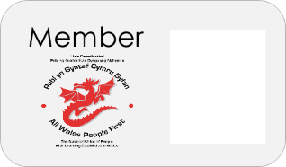
- To recruit new members for All Wales People First.

- To speak at events across Wales promoting All Wales People First, the benefits of being a member of All Wales People First and the importance of self-advocacy.

- To poll members once a month on an issue of importance to their lives.
- To deliver social events for the members of People First with a view to entertain, raise morale and survey members on issues of topical importance.
- To be the face of self-advocacy TV.

- To interview members (video and podcast) on issues of topical importance.

- Networking and promoting the organisation at events.

Supervision
You will attend regular supervision meetings to ensure that All Wales People First can fulfil their employment duties and to make sure you are supported with your professional development.

Health and Safety Requirements
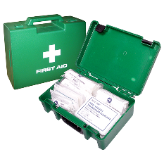
You will care for your own personal safety and that of others who may be affected by their acts or omissions.
You should report any hazardous situations or defective equipment supplied by All Wales People First to the Chief Executive.

Flexibility Statement
The job description is flexible and is subject to review and amendment, following consultation with the post holder.

Additional Information
The Outreach Worker will be a person who has lived experience of using learning disability services.
You will be provided with home office equipment such as a desk, chair, laptop, printer, and mobile phone.
You will be paid £26.00 per month to work from home.
Hours can be worked flexibly, in line with our organisation’s flexible working policy.

Statement of conduct
You are expected to always behave in a dignified and professional manner.

Confidentiality
All employees of All Wales People First are required to maintain the confidentiality of information

October 2020

All Wales People First
Person Specification - AWPF Outreach Worker.

Requirement | Essential | Desirable
Education, Training and Qualifications  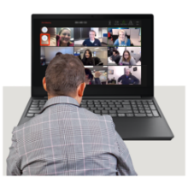 | Basic knowledge of IT:  - Word  - PowerPoint  - Emails  Able to host Zoom or other social platforms.
Skills and Knowledge | Understanding of self-advocacy.  Understanding of the People First/ self-advocacy movement in Wales. | Understands the principles of Easy Read.  Welsh language speaker.  Working collaboratively with organisations from voluntary and public sector
Experience  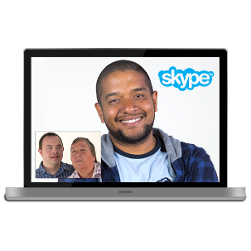 | Able to speak to large groups of people.  Comfortable in leading fun/ social events for people with learning disabilities.  Delivering Power Point presentations.  Comfortable speaking on video or Podcast.  Has lived experience of learning disability. | Experience of working in a member led organisation.
Personal attributes | Committed to the vision and values of All Wales People First.  Friendly and approachable and able to work in a collaborative way.  Highly motivated, flexible and resourceful.  Positive and outgoing personality.  A non-judgemental attitude.

