Coronavirus and people with learning disabilities

What is this study about?
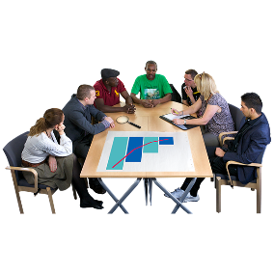 | This information is about the Welsh part of a UK-wide study that is going to happen soon. It is being done by researchers in Wales with help from some Welsh organisations.  Research means finding out new information. We need your help.
 | The study is being funded by UK Research and Innovation.
 | The coronavirus (Covid-19) pandemic has brought about a lot of changes for everybody. We want to find out what is happening to people with learning disabilities in Wales because of coronavirus.
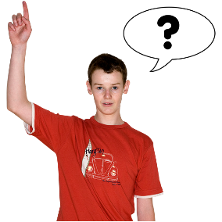 | We want to ask 200 people with learning disabilities about what has happened to them because of these changes.  Some adults with learning disabilities may not be able to talk to researchers so we would want also to speak to 100 family carers or paid support staff who could tell us about what has happened to those people too
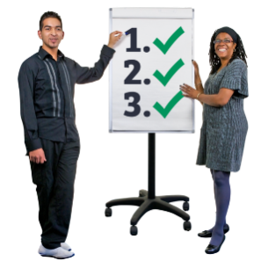 | We want to talk to these 200 people with learning disabilities and the 100 families or paid support staff three times over the next year to see if anything changes.
We hope that people with learning disabilities and their family carers or paid support staff will want to talk to us

The researchers will tell people who can make things better about what they have found so that they can think about what might need to happen to make things better for people with learning disabilities.

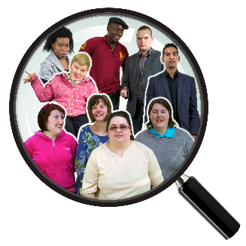 | We need help from organisations in Wales who help people with learning disabilities.  We need help to find people with learning disabilities who might like to talk to us.  We need help to find family carers or paid support staff who want to talk to us.
The research is being led in Wales by Professor Stuart Todd (stuart.todd@southwales.ac.uk) and Dr. Stephen Beyer (beyer@cardiff.ac.uk) - In collaboration with welsh organisations; Learning Disability Wales, All Wales Forum of Parents and Carers and All Wales People First

You could find out more about the research by asking Edward Oloidi (edward.oloidi@southwales.ac.uk) or contact any of the above listed collaborating organisations

