Weekly update bulletin – 23rd March 2020
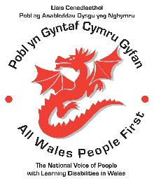
3rd April Photography Interviews. Cancelled
We will arrange another date when it is safe for everyone to be out and about.

12th May National Council meeting.
The face to face meeting will not go ahead.
We are looking at options for linking up with members through phone or video call.

19th May AWPF Board Meeting
The face to face meeting will not go ahead.
The Board will be meeting by video link using the Zoom app.

October 6th & 7th AdFest 2020
AdFest will not be going ahead this year.
The National Council decided that we will plan a 1 day 30th Birthday Celebration instead.
The date will be 7th October
The venue will be the Village Hotel, Cardiff

