Employment Statement
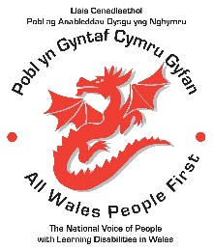
Employment
Many people with learning disabilities are able and willing to take part in paid work.

People with learning disabilities have the same right to employment as any other citizen in Wales.

Many people with learning disabilities want to work but are not given the opportunities.

Employment is important to well-being. We all need to have a purpose. People with learning disabilities are no different.

But in order to work we need more employers to create the right opportunities for work for people with learning disabilities.

Employers and colleagues need to get a better understanding about learning disability and be supportive to work colleagues who have a learning disability.

There are many things employers can do to help recruit people with learning disabilities.

Employers can create accessible interview formats and use accessible language in job advertisements and application forms.

Many people with learning disabilities have succeed in the workplace when given reasonable adjustments.

Reasonable adjustments can be beneficial for the whole workforce too. If you get it right for people with learning disabilities, you get it right for everyone.

It is important that people with learning disabilities are paid for their work. It is not right that many people with learning disabilities are only offered voluntary positions.

We call on governments, local authorities and the public and third sectors to create more employment opportunities for people with learning disabilities, so they can show the positive contribution people with learning disabilities can make to Welsh society.

We call on governments, local authorities and the public and third sectors to help us to challenge negative perceptions that are preventing people with learning disabilities from playing a full an active role as Welsh citizens.

Article 23 of the Universal Declaration of Human Rights outlines the right of all citizens to be able to work, be paid fairly and be free from discrimination. This includes people with learning disabilities.

NOTHING ABOUT US WITHOUT US!
Simon Richards, Chair, All Wales People First National Council.

