Position Statement
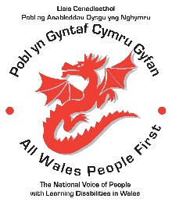
Sexual Relationships
People with Learning Disabilities have the same need to access loving and stable relationships as any other citizen in Wales. This includes intimate and sexual relationships.
People with learning disabilities are often not seen as ‘sexual beings’ or being mature enough to engage in serious relationships. People with learning disabilities are NOT CHILDREN. They have a fundamental right to access intimate or sexual relationships as laid out in the UN Conventions of the Rights of Persons with Disabilities (CRPD).
It is also important that people with learning disabilities are able to explore their sexuality and gender identity and be given the appropriate encouragement and support to do so. People with learning disabilities who identify as being lesbian, gay or bi-sexual should be given the freedom, education and support to have opportunities to establish loving and intimate relationships with a partner of their choice.
People with learning disabilities who identify as having a different gender than the one assigned at birth, should be given the emotional and psychological support necessary to accept their gender identity and to feel comfortable to dress and live as they choose.
We urge all care providers, educational establishments, public institutions and relatives of people with learning disabilities to recognise this fundamental human right and to support people with learning disabilities to realise those rights.
Access to relationships and the freedom to live as the gender a person feels is appropriate is essential for personal well-being and the prevention of distress and avoidable mental health difficulties. We ask that you all join us in empowering people with learning disabilities to achieve their right to access loving relationships they choose and/ or to live as the gender they identify as.
NOTHING ABOUT US WITHOUT US!
Simon Richards, Chair of the All Wales People First National Council.
In consultation with the All Wales People National Council.

