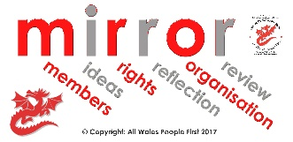 | Using MIRROR to make policies
Agreed by on

Date for next check:

 | All Wales People First uses MIRROR as a way to remember important things about being a People First organisation.

 | MIRROR stands for:
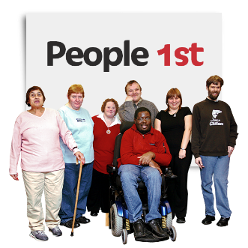 | - Member-led
 | - Ideas
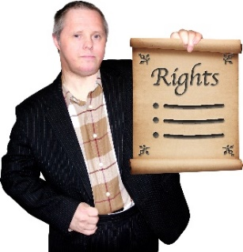 | - Rights
 | - Reflection
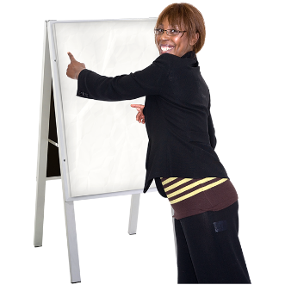 | - Organisation
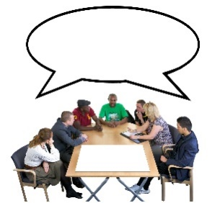 | - Review
 | Member-led
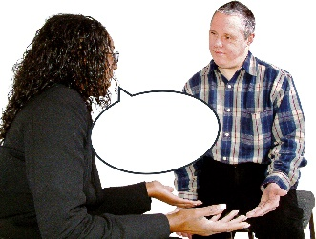 | Members need to listen to advice from staff and any Board members.
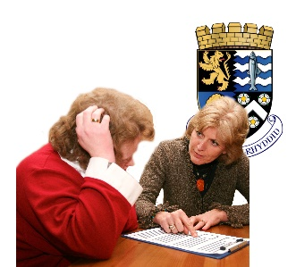 | Members can ask staff or Board members to write a policy.
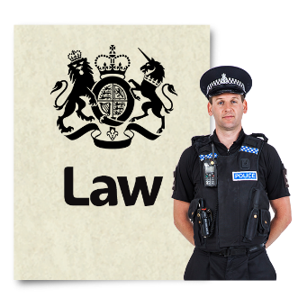 | Policies must follow the law.
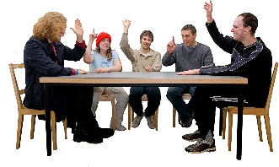 | Nothing is a policy until the members agree the policy.

 | This may mean:
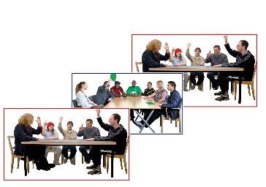 | - the members committee agreeing it  - a members meeting agreeing it  - a vote of all members at the Annual General Meeting.
 | Members need to remember that if staff or volunteers disagree strongly with a policy, they can choose to leave.
 | Ideas
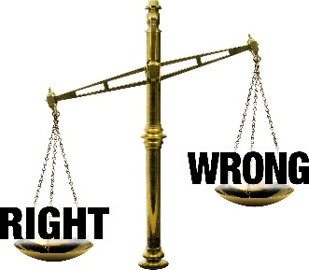 | The MIRROR pack has examples of policies. But it is up to your organisation to have your own ideas about what is right for you.

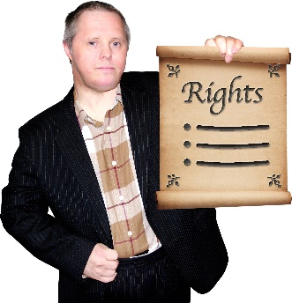 | Rights
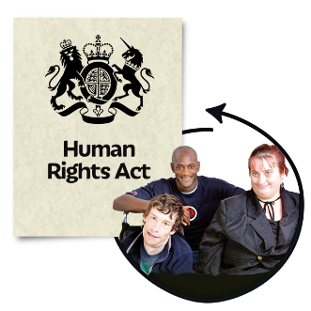 | Policies should always help members to use their human rights and their legal rights.
 | Reflection
 | Do not write policies in a rush!
 | Take time to think about what is right for your organisation.
 | Take time to ask people for advice and ideas.
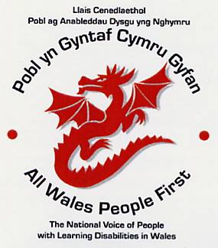 | Organisation
 | Good organisations need good policies.
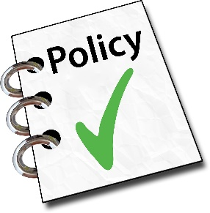 | The right policies help you to be a well-run organisation.
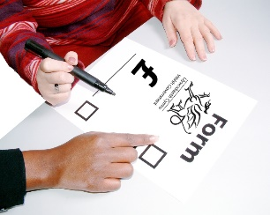 | The right policies also help when you apply for grants and contracts.
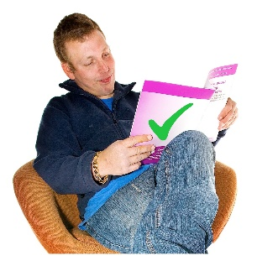 | There is no point having policies unless the organisation does what the policies say.
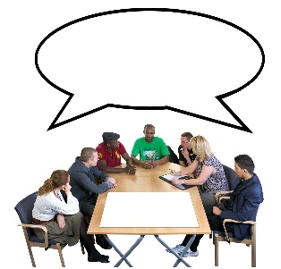 | Review
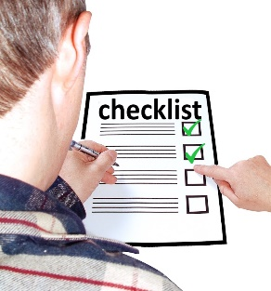 | Agree how often you will check to make sure your policies are:
 | - being used
 | - working well
 | - legal

