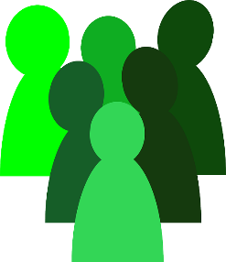 | Different roles in  All Wales People First
Policy agreed by Date

Date of next check:

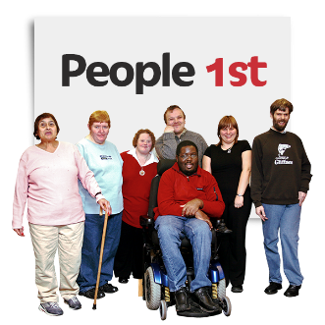 | All Wales People First is a member-led organisation.
 | In All Wales People First, people have different roles.

 | What are the roles?
 | You might be:
 | - a member
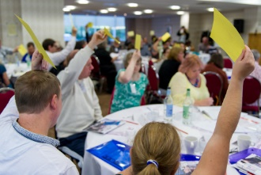 | - on the National Council
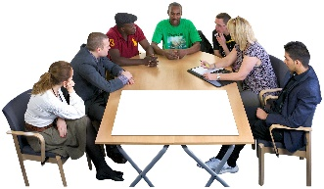 | - on the Board of Directors
 | - a member of staff
 | You may have more than one role.
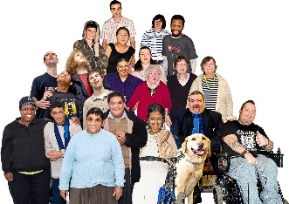 | About Members
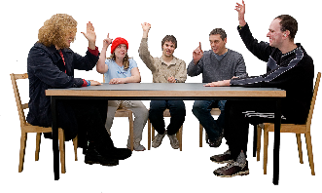 | Members vote at the AGM about any important changes to All Wales People First.
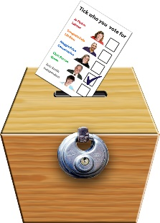 | Members vote for someone to represent them at the National Council.
 | About the National Council
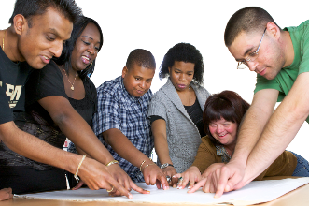 | The National Council decides what work All Wales People First should do.
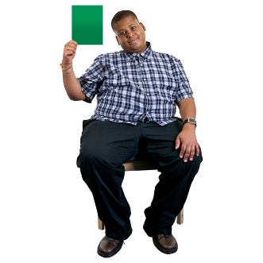 | The National Council votes to say who can be on the Board of Directors.
 | About the Board of Directors
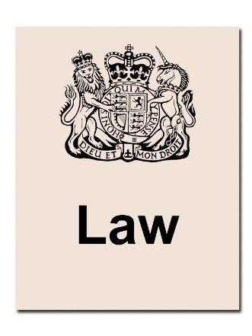 | The Board of Directors deals with the legal side of All Wales People First
 | The Board gives advice to the National Council.

 | About staff
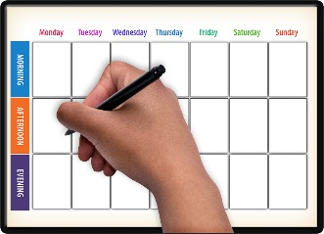 | Staff do the day to day work of All Wales People First.
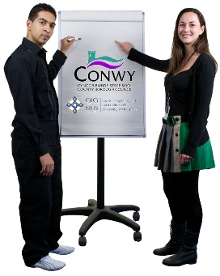 | Staff give advice to the Board of Directors and the National Council.

How the roles work together 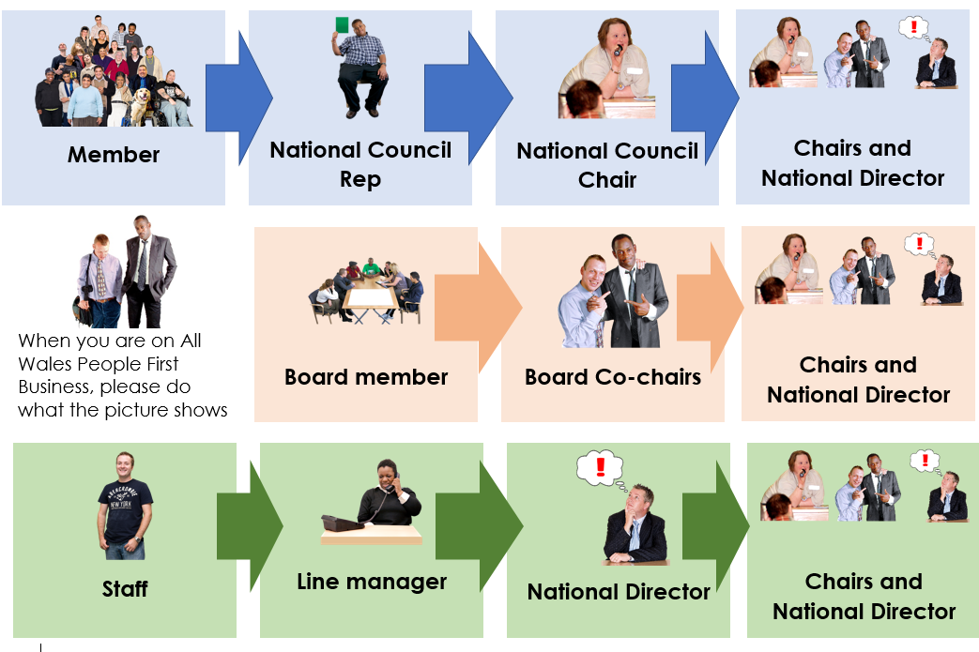

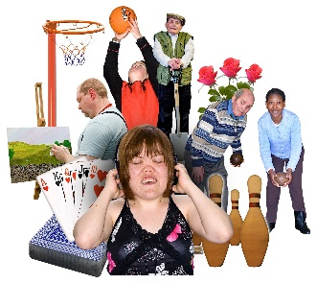 | Being friends
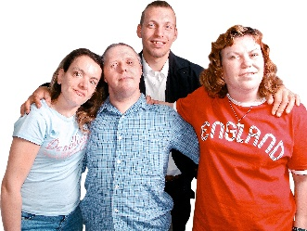 | It is OK to be friends with people who you met through All Wales People First.
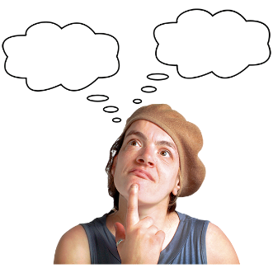 | Always be clear why you are meeting. Is it work, or is it social?
 | Do not talk about All Wales People First business when you meet socially.

