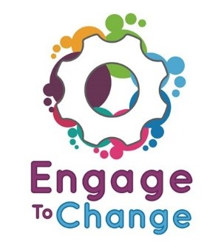
Engage to Change Project
All Wales People First
Project Ambassador
£705 per annum
75 hours per annum
6 Employer’s pension contributions
Fixed term until 31st May 2021
A home-based all-Wales post with extensive travel across Wales.
Engage to Change is a 5-year project to create and support long term employment opportunities for young people aged 16 to 25 with a learning disability / difficulty, and/or Autistic Spectrum Disorder (ASD).
Do you want to play a key role in a project that will change the way young people with a learning disability / difficulty, and/or ASD become engaged in paid work placements and contribute to the workforce in Wales?
As a Project Ambassador, you will travel throughout the county you live in and the neighbouring county areas talking to small groups of young people about the project and your work experience. You will also talk to potential employers about the project and your work experience, visit schools to talk at careers fairs, and take part in photoshoots for promotional material. There will initially be 3 Ambassadors covering all of Wales.
To find out more and for a job application pack, please visit our website www.allwalespeople1st.co.uk or email info@allwalespeople1st.co.uk
The Engage to Change project is funded from the dormant account investments, delivered by the Big Lottery Fund in partnership with Welsh Government via the Getting Ahead 2 Programme. The project is delivered in partnership between Learning Disability Wales, Agoriad Cyf, All Wales People First, Cardiff University, ELITE and in collaboration with Project SEARCH.
Closing Date: 5pm Friday 27th April
Interviews: Wednesday 16th May

