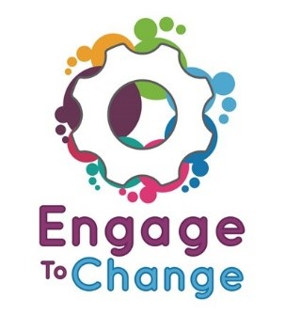 Engage to Change
Project Ambassador
Job Description / Person Specification

Aim of Post: Engage to Change is a 5 year project to create and support long term youth employment opportunities, for 16 to 25 year olds with a learning disability and/or learning difficulty, including ASD, to be engaged in paid work placements and develop their employability skills.
The Engage to Change Project will organise a wide range of sessions, talks, open days, school visits, and visits to potential employers to encourage participation in the project. As a Project Ambassador you will represent and promote the project at these events.
Salary: (NJC point 18) £18,070 full time equivalent
Hours: 10 days per year (equivalent to 75 hours per year)
Accountable to: Lead Ambassador.
Location: The role will require you to travel throughout the county you live in and the neighbouring county areas. There will be initially 3 Ambassadors covering all of Wales. Detail of areas covered will be negotiated with the successful candidates.
Main Duties
- Talking to small groups of young people about the project and your work experience.
- Talking to potential employers about the project and your work experience.
- Visit schools to talk at careers fairs.
- Give out promotional leaflets and application forms to potential project students.
- Take part in photoshoots for promotional material.

Special Conditions

The post holder will be promoting the Engage to Change project and the benefits of employment and they must have been employed through the project.

Person Specification

 | Essential | Desirable
Experience/Qualification | - Supported through project Engage to Change.  - Must have been employed
Skills/Abilities | - Good verbal communication skills.  - Can work on your own or as part of a team.  - Able travel independently.  - Knowledge of Engage to Change. | - Experience of talking to groups of people.  - Experience of promoting something
Personal | - Reliable  - Responsible

The post holders will be selected by interview and training sessions will be held for all Ambassadors.

