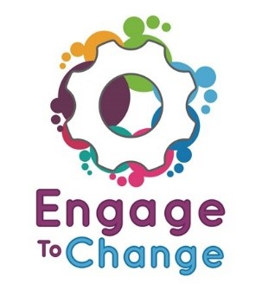
Engage to Change Project
All Wales People First
Lead Ambassador
£8,934 per annum,
16 hours per week,
plus 6% Employer’s pension contribution. Fixed term until 31st May 2021
An all Wales post, homebased, with extensive travel across Wales.
Engage to Change is a 5 year project to create and support long term youth employment opportunities, for 16 to 25 year olds with a learning disability / difficulty, including Autistic Spectrum Condition (ASC).
As the project’s Lead Ambassador, you will be a person who has a learning disability or autism spectrum condition. The Lead Ambassador will organise and support the Project Ambassadors, whilst also encouraging participation by promoting the project at a wide range of events including open days, school visits, and visits to potential employers.
Have you received support from the Engage to Change Project?
Have you been in paid employment for at least 6 months?
Do you have experience of talking to groups of people?
Do you want to play a key role in a project that will change the way young people with a learning disability / difficulty, including ASC, contribute to the workforce in Wales?
We would love to hear from you!
To find out more and for a job application pack, please visit our website www.allwalespeople1st.co.uk or email info@allwalespeople1st.co.uk
The Engage to Change project is funded from the dormant account investments, delivered by the Big Lottery Fund in partnership with Welsh Government via the Getting Ahead 2 Programme. The project is delivered in partnership between Learning Disability Wales, Agoriad Cyf, All Wales People First, Cardiff University, ELITE and in collaboration with Project SEARCH.
Closing date for applications: 5pm 22nd December
Interview: 2-day interview process on 23 and 24 January 2018

