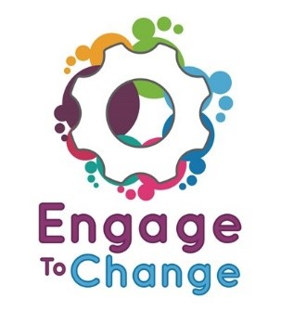
Engage to Change Project
All Wales People First

Lead Ambassador
You would be paid £8, 934 per year for working 16 hours each week.

Plus, we would pay 6% towards your pension

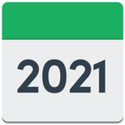  31stMay | The job is fixed term. This means it will finish on 31st May 2021.
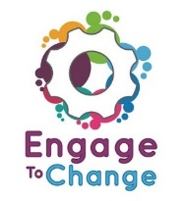 | Have you been supported by the Engage to Change Project?  Have you had a paid job for more than 6 months?  Do you have experience of talking to groups of people?  If you have said Yes to these questions you might be the Lead Ambassador we are looking for.
The Lead Ambassador will

- work from home

- travel lots around Wales

- go to meetings in Cardiff each month.

The Lead Ambassador will attend lots of different events to tell people about the Engage to Change Project.

The Lead Ambassador will also help other Project Ambassadors to plan their work and promote the project.
If you would like to find out more or to get an application form visit our

website allwalespeople1st.co.uk

or

Email info@allwalespeople1st.co.uk

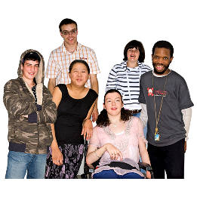 | The Engage to Change project is for  - young people with a learning disability  - young people with Autistic Spectrum Disorder or ASD  - young people aged 16 to 25  - young people who are not in work or education.  The project will help 1000 young people in Wales to find work.
 | The Engage to Change project is funded from the dormant account investments, delivered by the Big Lottery Fund in partnership with Welsh Government via the Getting Ahead 2 Programme. The project is delivered in partnership between Learning Disability Wales, Agoriad Cyf, All Wales People First, Cardiff University, ELITE and in collaboration with Project SEARCH. www.engagetochange.org.uk

