All Wales People First

Annual General Meeting 2019

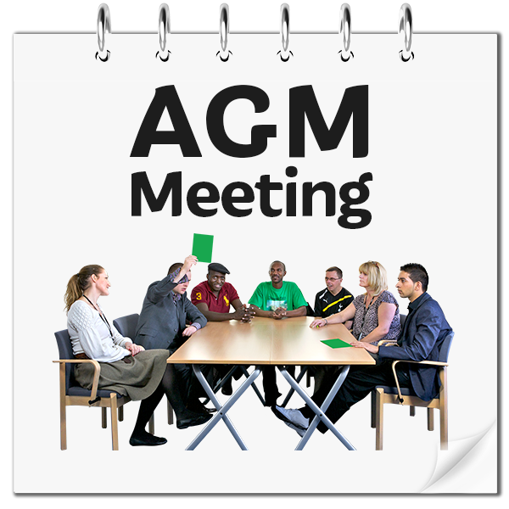

Village Hotel, Cardiff
17th October 2019, 1.30pm

Agenda
Thursday 17th October 2019

1. Minutes and Matters arising from 2017/18 Annual General Meeting
Members chance to discuss things from the minutes

2. The 2018/2019 Annual Report (Highlights)
Joe Powell (Chief Executive)

3. Questions and Answers
Members chance to ask questions on the Annual Report.

4. The Finance Report
Victoria Sidwell-Brown (Business and Finance Manager, All Wales People First).

5. Questions and Answers
Members chance to ask questions on the Finance Report.

6. Adopting the report
Members to adopt the report.

7. Retirements from the Board of Directors
(Bryan Collis, Sophie Hinksman, John Thomas).

8. The National Council 2018/2019
Simon Richards (Chair of the National Council)

9. Thanks

