Whistleblowing
Agreed by on

Date for next check:

Whistleblowing means speaking up when you see or think you see something that is wrong.

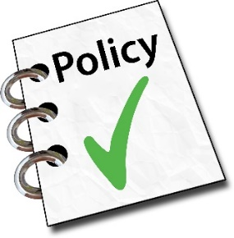 | We have a whistleblowing policy so you can
 | - go to someone independent to ask advice
 | - go to the Co-Chairs, not just your line manager
 | We want people to speak up if they see something that is wrong.
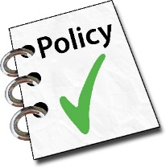 | You will not be in trouble for speaking up as long as you follow this procedure.
 | We will make sure no-one is allowed to treat you badly because you spoke up.
 | But if you deliberately lie to get someone into trouble, we will take action against you.
 | We will not do this if you made a mistake or misunderstood the situation.

 | If you want to speak up about something wrong that has been done to you, please use:
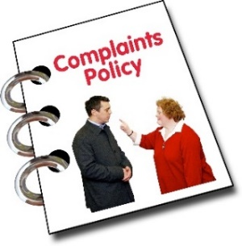 | - complaints for members
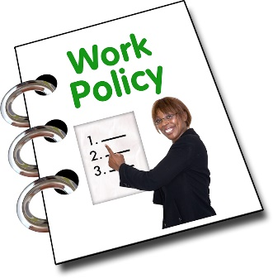 | - grievance for staff
 | - harassment procedure

 | Whistleblowing procedure
 | You may go to any of these groups for independent advice at any time
 | - ACAS, Public Concern at Work or another helpline for people who want to whistleblow.
 | - The Police, if a crime has been committed
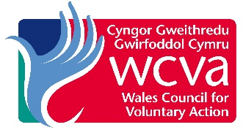 | - WCVA
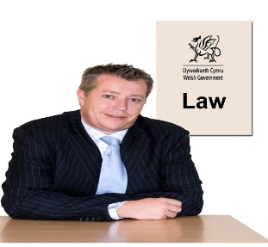 | - any solicitor or law firm
 | Whistleblowing
 | You may officially tell either of these people about your worries and ask them to investigate:
 | - Co-Chairs of the Board
 | - Senior staff member

 | They will:
 | - listen to you
 | - write down what you say
 | - investigate (without saying it was you who told them about the problem)
 | - tell you what they have decided to do
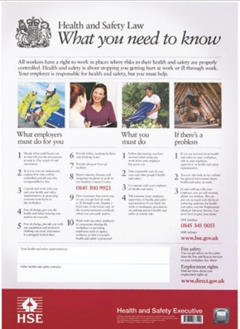 | If your worry is about health and safety, you can go to the Health and Safety Executive.
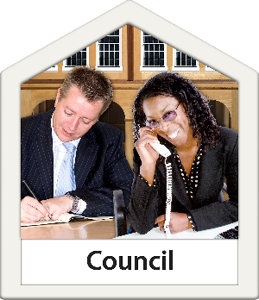 | If your worry is about the safety of vulnerable adults, you can tell anyone named on the local council’s Safeguarding policy.
 | If you do not think we have taken your worries seriously, you may follow advice officially given by ACAS or a legal firm.

Remember
If you use this procedure, we will not treat you badly and we will not let anyone else treat you badly for speaking up.

