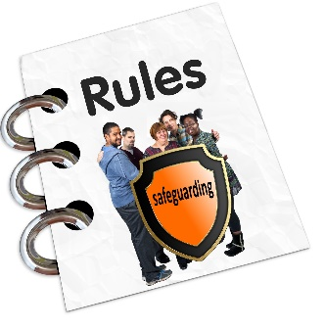 | Safeguarding Policy
Agreed by on

Date for next check:

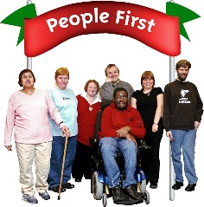 | Our organisation wants to be a safe place for everyone.

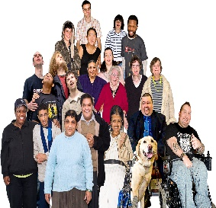 | We expect everyone to:
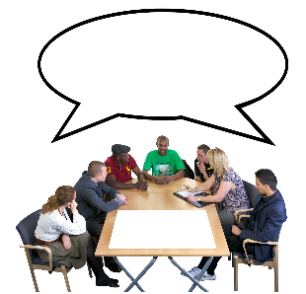 | - think about keeping themselves safe
 | - think about keeping other people safe
 | - speak up if they see or hear anything that worries them
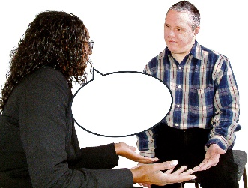 | - speak up if they see or hear anything that makes them think someone might be unsafe
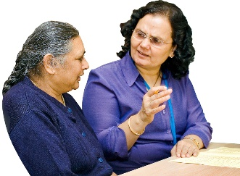 | You can talk to The Business and Finance Manager if
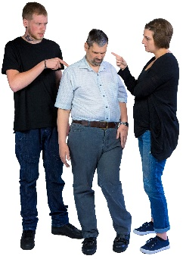 | - you feel unsafe or think someone may be abusing you
 | - you are worried about how someone is behaving
 | - you are worried someone is being treated badly
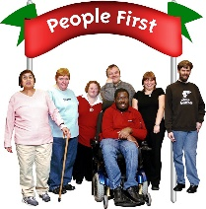 | - you think our organisation could be safer
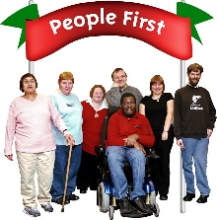 | We will change things to make our organisation a safer place.
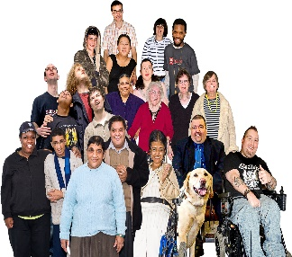 | Everyone will be listened to with respect.
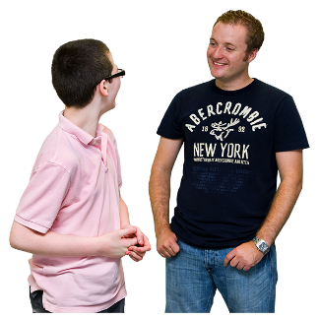 | The law says all people under 18 and some adults need extra protection to be safe. Adults who need extra protection are called vulnerable adults.
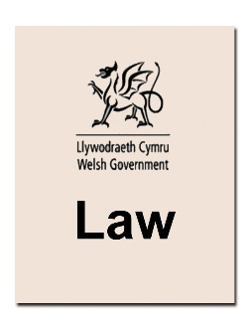 | The law says a vulnerable adult is someone who:
 | - gets help from any learning disability service or from Social Services and
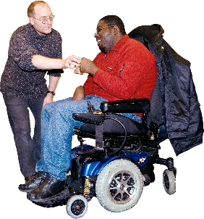 | - may not be able to take care of themselves without support or
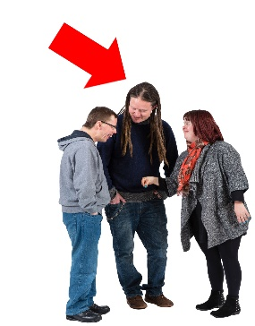 | - may not be able to keep themselves safe from abusers without support
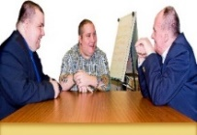 | This means some of our members, staff, volunteers and Board members may be vulnerable adults.
We will follow the law about making sure vulnerable adults get extra protection.
This means we will:

 | - make sure vulnerable adults are not supported in one to one ways outside the sight and knowledge of others
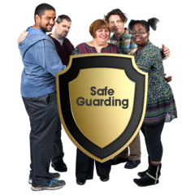 | - help Staff, Volunteers, and Board Members to understand what their behaviour means and know their Safeguarding responsibilities
 | - make decisions about safeguarding that balance a vulnerable adult’s safety and their freedom to take risks.
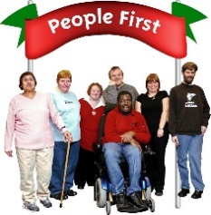 | - keep records of decisions taken about safeguarding a vulnerable adult that includes details of everyone who helped to make the decision.
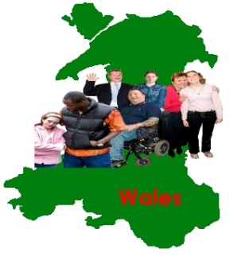 | As well as this, each part of Wales has
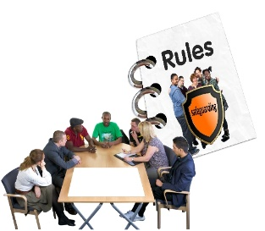 | - a Local Safeguarding Board. Ours is Gwent-wide Adult Safeguarding Board.
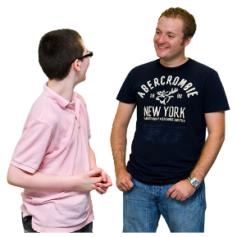 | - someone in Social Services to contact about keeping vulnerable adults safe. Ours is Newport Social Services  telephone: 01633 656656,  email: pova.team@newport.gov.uk
 | - a Safeguarding Policy and Procedures that everyone must follow for anyone under 18 and vulnerable adults. You can get a copy from The Business and Finance Manager
t | We will make sure all staff, volunteers and Board members know what to do if someone tells them worries about abuse or being unsafe.
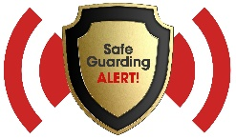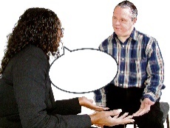 | We will follow the advice of our Local Safeguarding Board if someone tells us about abuse, being unsafe or worrying that a person is unsafe.
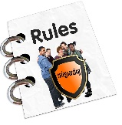 | We will follow the official Safeguarding Policies and Procedures.
 | We will train staff, volunteers and Board members about safeguarding.
 | All staff who need DBS checks have them in place.

