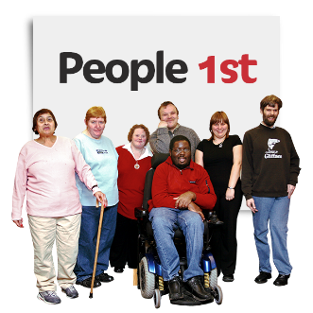 | Member led policy
Agreed by Date

Date of next check:

 | All Wales People first is a member-led organisation.
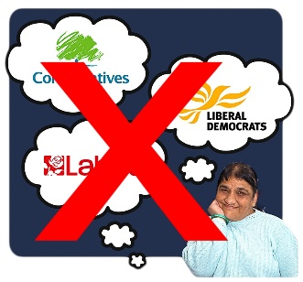 | All Wales People First does not support any political party.
 | All Wales People First listens to its members.
 | All Wales People First supports members to speak up.
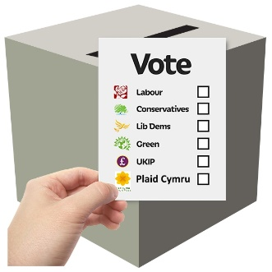 | All Wales People First supports members to know how to vote.

 | Member-led means:
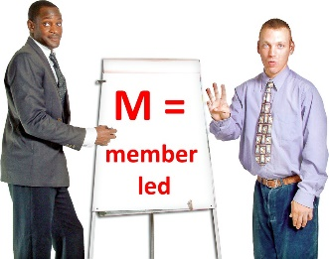 | - our members have a vote at the Annual General Meeting
 | - members vote for their National Council representative
 | - the National Council decides what work All Wales People First wants to do.

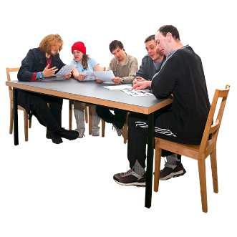 | All Wales People First has a Board of Directors.
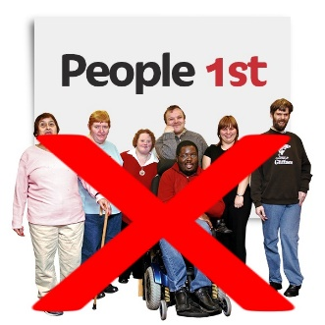 | Most of the Board are not full voting members of All Wales People First.
 | Usually a Board has most of the power.
 | In All Wales People First, the Board has given most of the power to the National Council.

 | The Board of Directors:
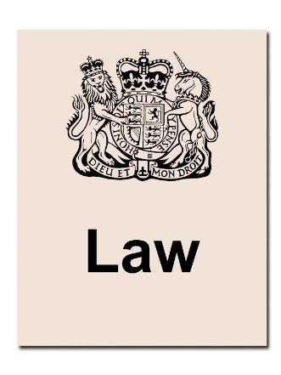 | - deals with laws
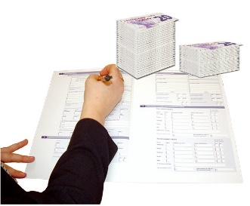 | - deals with money
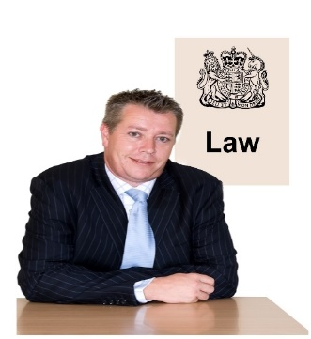 | - deals with laws about employing people
 | - gives advice to the Chair and Vice-chair of the National Council

 | The Board can only stop the National Council if the National Council wants to:
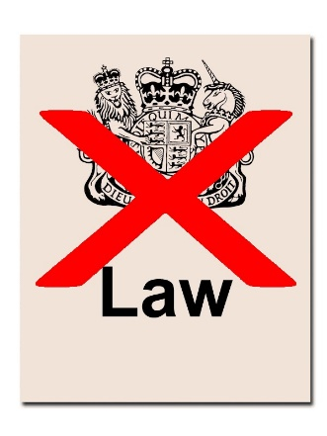 | - break the law
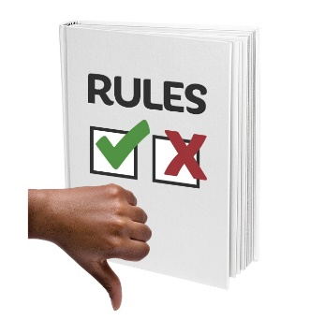 | - break All Wales People First’s rules
 | - spend money that All Wales People First does not have
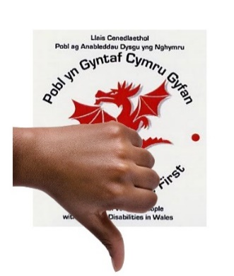 | - do things that will give All Wales People First a bad name

