 |  | Being a member
Agreed by Date

Date of next check:

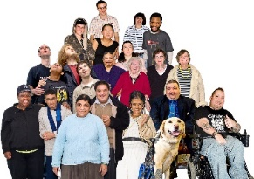 |  | People First organisations are member-led.
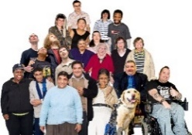 |  | This means they are run by the members for the members.
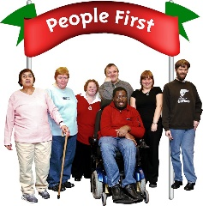 |  | If you are a member it is your organisation
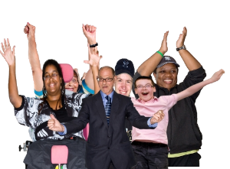 |  | All members help the organisation to make decisions.  All members help each other.
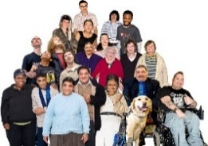  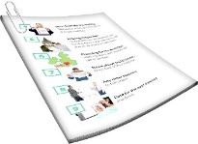 |  | Here is some important information for members:
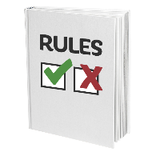  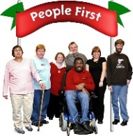 |  | - You need to follow the organisation’s rules
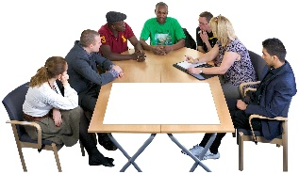 |  | - It is important to come to members’ meetings
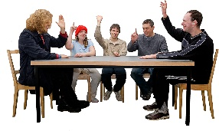 |  | - you can vote at members’ meetings
 | 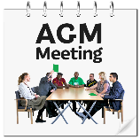  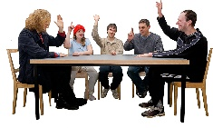 |  | - you can vote at the Annual General Meeting
 | 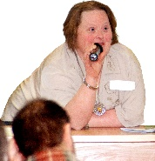 |  | - you can speak up at members’ meetings
 | 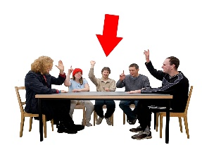 |  | - you can stand for election to the members’
 | 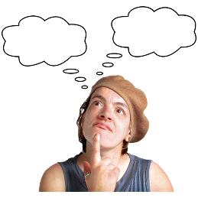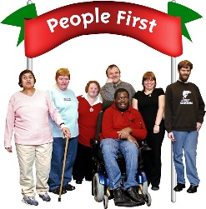 |  | - you can suggest ideas for the organisation

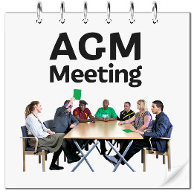 | The Annual General Meeting
 | This is the most important meeting of the year.
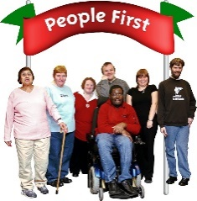 | Each organisation has its own rules about how to run an Annual General Meeting.
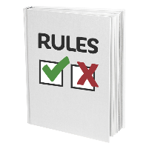 | The rules for the Annual General Meeting are in your constitution.

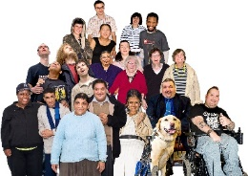 | Members come to the Annual General Meeting to:
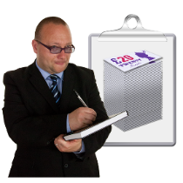 | - find out how much money comes into the organisation
 | - find out how much money the organisation has spent
 | - find out how much money the organisation has in the bank
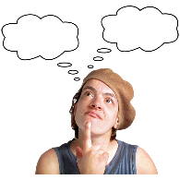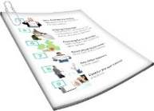 | - hear about plans for next year
 | - vote for who is on the members’ committee
 | - vote for who is on the Board
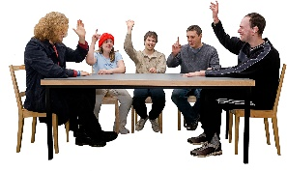 | - vote on big decisions
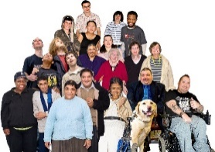 | Every member has a vote.
 | It is important to use your vote.
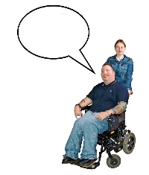 | When you vote, you are having a say.
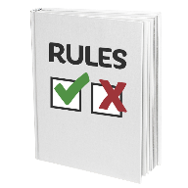 | Your organisation will have rules about:
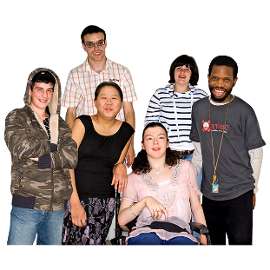 | - how many people are on the members’ committee
 | - how long someone is on the members’ committee
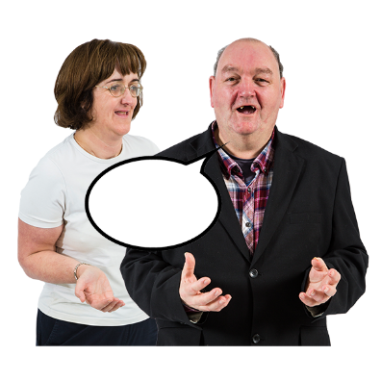 |  | - how to speak up if you want to be on the members’ committee
 |  | - how to vote for someone to be on the members’ committee
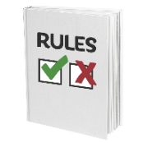 |  | Ask the Chair to tell you the rules. A member of staff could support you.

