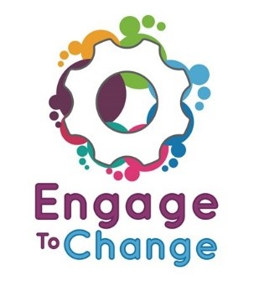
Engage to Change Project
All Wales People First

Project Ambassador
You would be paid £705.00 per year for working 75 hours a year.

Plus, we would pay 6% towards your pension

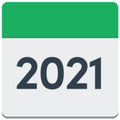  31stMay | The job is fixed term. This means it will finish on 31st May 2021.
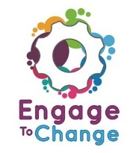 | Have you been supported by the Engage to Change Project?  Have you had a paid job?  Do you have experience of talking to groups of people?  If you have said Yes to these questions you might be the Project Ambassador we are looking for.
The Ambassador will

- work from home

- travel lots around their county and counties close by

- talk to people about your work.

 | The Ambassador will attend events to tell people about the Engage to Change Project.
If you would like to find out more or to get an application form visit our

website allwalespeople1st.co.uk

or

Email info@allwalespeople1st.co.uk

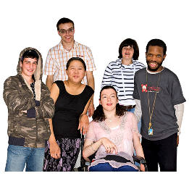 | The Engage to Change project is for  - young people with a learning disability  - young people with an Autistic Spectrum Condition or ASC  - young people aged 16 to 25  - young people who are not in work or education.  The project will help 1000 young people in Wales to find work.
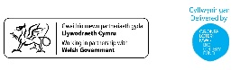 | The Engage to Change project is funded from the dormant account investments, delivered by the Big Lottery Fund in partnership with Welsh Government via the Getting Ahead 2 Programme.  The project is delivered in partnership between Learning Disability Wales, Agoriad Cyf, All Wales People First, Cardiff University, ELITE and in collaboration with Project SEARCH. www.engagetochange.org.uk  Please send your application to us by 5pm on Thursday 23rd August  Interviews will happen on Tuesday 4th September  There will be a 2-day introduction to the job in South Wales on Monday 17th and Tuesday 18th September.  