Complaints Policy and Procedure
Agreed by on

Date for next check:

Sometimes things go wrong.
We want to put things right for the person who has complained.

We will:
- tell people how to make a complaint
- make the complaints procedure fair to everyone
- make it easy to make a complaint
- make sure we know what to do if someone complains
- try to put things right for the person who has complained as soon as we can.

Who can complain using this policy?
Members can use this policy.
Members of the public can use this policy.
If staff want to complain they need to use our Grievance Policy.

 | Telling people about our complaints policy
 | We will put this information on our website:
 | - this complaints policy
 | - an ‘I’m not happy’ leaflet that says how to complain
 | - who to contact, and how to contact them
 | Information for staff, volunteers or Board members
 | What to do if you get a complaint in person or over the phone
 | - Stay calm and be polite
 | - If the person is speaking to you, you need to:
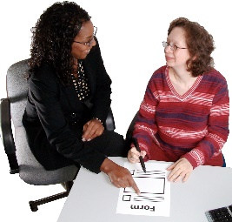 | - ask them for their name, address and telephone number and write it down
 | - write down their complaint
 | - tell them about the complaints procedure
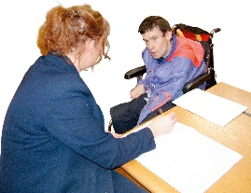 | - Tell the person who made the complaint what you are doing next.
 | - Tell the person who made the complaint what you can do to put it right. Do not promise things that you cannot do.
 | - If you cannot put it right, tell the person you will talk to your line manager and someone will get back to them soon. If you are a Board member, say you will talk to the Chair.
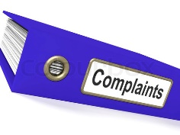 | - Record every complaint in a Complaints Log.

 | What to do if you get a written complaint
 | Give the letter or email to your line manager. If you are a Board member, give it to the Co-Chairs.
 | The senior staff member and Co-Chairs need to be told about any written complaints.
 | The person dealing with the complaint will:
 | - speak to the person making the complaint
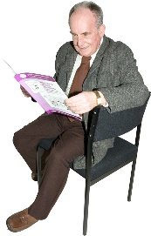 | - find out more information
 | - decide what to do about the complaint
 | - check with the senior staff member and Co-Chairs to make sure they agree
 | - write to tell the person what has been decided

 | What to do if the person complains that their complaint wasn’t treated fairly
 | If someone is not happy with how we dealt with their complaint, they can ask the Co-Chairs and Board to look at their complaint.
 | The Co-Chairs and Board will:
 | - tell the person that they are looking at the complaint
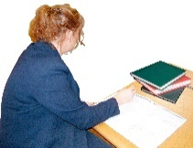 | - look at what has been written about the first time they complained
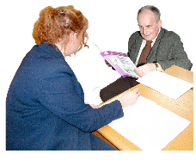 | - talk to whoever dealt with the complaint already
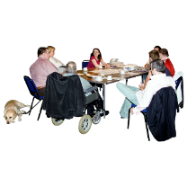 | - if the complaint is about a person, tell this person and allow them to tell the Co-Chairs and committee what happened.
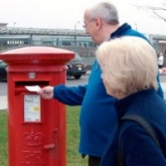 | - send the person a progress report if the answer is going to take longer than 4 weeks.
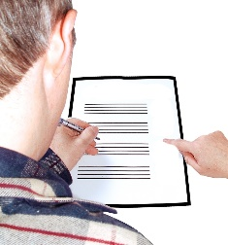 | - write to the person who made the complaint. Tell them:
 | - how you looked at what happened
 | - what you found out
 | - whether you have decided to do anything or not.
 | The Co-Chairs and Board’s answer is final.

 | ‘I’m not happy’ leaflet
 | We want to know if you are not happy.
 | Sometimes we can put things right just by talking together and agreeing what to do.
 | Sometimes you may want to make a formal complaint.
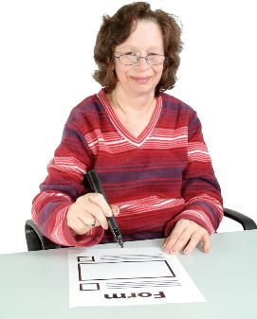 | You will need to write to us, or ask someone to write to us on your behalf. You need to tell us:
 | - Why you are not happy
 | - What you would like us to do
 | We will read your letter.
 | We will decide who will deal with your complaint.
 | If your complaint is about abuse, we will use the Safeguarding Policy, not the complaints policy.
 | One of us will talk to you to find out more. They may need to talk to other people in the organisation too.
 | We will think what we can do to put things right.
 | We will write to tell you what we have decided.
 | If you are not happy with our reply, you can write to the Co-Chairs and ask the Board to look at your complaint.

Learning from complaints
We want to learn from complaints.
We do not want people to be unhappy.
We will keep a Complaints Log where we write down any complaints.
Our Co-Chairs and Board will look at the Complaints Log every year.
They will
- look to see if the same kind of thing has gone wrong more than once
- think how the organisation can do things better

