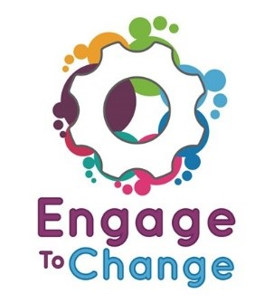
Engage to Change Project
All Wales People First
Lead Ambassador
£8,934 per annum,
16 hours per week,
plus 6% Employer’s pension contribution. Fixed term until 31st May 2021
An all Wales post, homebased, with extensive travel across Wales.

Engage to Change is a 5 year project to create and support long term youth employment opportunities, for 16 to 25 year olds with a learning disability / difficulty, including Autistic Spectrum Disorder (ASD).
Do you want to play a key role in a project that will change the way young people with a learning disability / difficulty, including ASD, become engaged in paid work placements and contribute to the workforce in Wales?
The project’s Lead Ambassador will organise and support the Project Ambassadors whilst also representing and promoting the project at a wide range of events including open days, school visits, and visits to potential employers, to encourage participation in the project.
To find out more and for a job application pack, please visit our website www.allwalespeople1st.co.uk or email info@allwalespeople1st.co.uk
The Engage to Change project is funded from the dormant account investments, delivered by the Big Lottery Fund in partnership with Welsh Government via the Getting Ahead 2 Programme. The project is delivered in partnership between Learning Disability Wales, Agoriad Cyf, All Wales People First, Cardiff University, ELITE and in collaboration with Project SEARCH.

